Dynamics 365 / Dataverse – Plugin Interview Notes + Syntax (Consolidated)

Microsoft References (Links)
- Understand the execution context: https://learn.microsoft.com/power-apps/developer/data-platform/understand-the-data-context
- IExecutionContext (.NET API): https://learn.microsoft.com/dotnet/api/microsoft.xrm.sdk.iexecutioncontext?view=dataverse-sdk-latest
- IPluginExecutionContext (.NET API): https://learn.microsoft.com/dotnet/api/microsoft.xrm.sdk.ipluginexecutioncontext?view=dataverse-sdk-latest
- IOrganizationService interface: https://learn.microsoft.com/power-apps/developer/data-platform/org-service/iorganizationservice-interface
- IOrganizationService.Retrieve signature: https://learn.microsoft.com/dotnet/api/microsoft.xrm.sdk.iorganizationservice.retrieve?view=dataverse-sdk-latest
- Use ITracingService in plug-ins: https://learn.microsoft.com/power-apps/developer/data-platform/best-practices/business-logic/use-itracingservice-plugins
- Best practices for plug-in and workflow development: https://learn.microsoft.com/power-apps/developer/data-platform/best-practices/business-logic/
- Register a plug-in: https://learn.microsoft.com/power-apps/developer/data-platform/register-plug-in

- Asynchronous service (async plug-ins & workflows queue): https://learn.microsoft.com/power-apps/developer/data-platform/asynchronous-service

- Create real-time workflows (pipeline stages & rank) (CE on-prem dev guide): https://learn.microsoft.com/dynamics365/customerengagement/on-premises/developer/create-real-time-workflows?view=op-9-1

Plugin Basic Syntax
. Basic Plugin Structure
Note –
1.Service provider- contextual tools you need to run your plugin
2.Impersonization -
Run in User's Context is a plugin step configuration that determines the security context in which the plugin executes. If set to Calling User, context.UserId represents the user who triggered the action. If set to a Specific User, context.UserId becomes that configured user, while context.InitiatingUserId still refers to the original user who initiated the operation. This is commonly used to execute plugin logic with elevated privileges.
But you can still override it:
C#serviceFactory.CreateOrganizationService(someOtherUserId);

using Microsoft.Xrm.Sdk;

public class AccountPlugin : IPlugin
{
public void Execute(IServiceProvider serviceProvider)
{
IPluginExecutionContext context =
(IPluginExecutionContext)serviceProvider.GetService(typeof(IPluginExecutionContext));

IOrganizationServiceFactory serviceFactory =
(IOrganizationServiceFactory)serviceProvider.GetService(typeof(IOrganizationServiceFactory));

IOrganizationService service =
serviceFactory.CreateOrganizationService(context.UserId);

ITracingService tracingService =
(ITracingService)serviceProvider.GetService(typeof(ITracingService));

try
{
// Logic
}
catch (Exception ex)
{
tracingService.Trace(ex.ToString());
throw new InvalidPluginExecutionException(ex.Message);
}
}
}
Show more lines

2. Get Target Entity
Create/Update
C#
Entity entity = (Entity)context.InputParameters["Target"];
Show more lines
Safe way:
C#
if (context.InputParameters.Contains("Target") &&
context.InputParameters["Target"] is Entity entity)
{
}
Show more lines

3. Get Attribute Value
String
C#
string name = entity.GetAttributeValue<string>("name");
Show more lines
DateTime
C#
DateTime createdOn = entity.GetAttributeValue<DateTime>("createdon");
Show more lines
Decimal
C#
decimal amount = entity.GetAttributeValue<decimal>("new_amount");
Show more lines
Boolean
C#
bool isActive = entity.GetAttributeValue<bool>("new_active");
Show more lines

4. Lookup Field
Get Lookup
C#
EntityReference customer =
entity.GetAttributeValue<EntityReference>("parentcustomerid");

Guid customerId = customer.Id;
string customerName = customer.Name;
Show more lines

5. Option Set
Single Option Set
C#
OptionSetValue status =
entity.GetAttributeValue<OptionSetValue>("statuscode");

int statusValue = status.Value;
Show more lines
Set Option Set
C#
entity["new_priority"] = new OptionSetValue(100000001);
Show more lines

6. Multi Select Option Set
C#
OptionSetValueCollection options =
entity.GetAttributeValue<OptionSetValueCollection>("new_skills");

foreach(var item in options)
{
int value = item.Value;
}
Show more lines

7. Money Field
C#
Money revenue =
entity.GetAttributeValue<Money>("revenue");

decimal revenueAmount = revenue.Value;
Show more lines
Set money:
C#
entity["revenue"] = new Money(5000);
Show more lines

8. Retrieve Record
C#
Entity account = service.Retrieve(
"account",
accountId,
new ColumnSet("name", "telephone1")
);
Show more lines

9. Update Record
C#
Entity account = new Entity("account");
account.Id = accountId;

account["name"] = "Updated Account";

service.Update(account);
Show more lines

10. Create Record
C#
Entity task = new Entity("task");

task["subject"] = "Follow Up";

Guid taskId = service.Create(task);
Show more lines

11. Delete Record
C#
service.Delete("account", accountId);
Show more lines

12. Pre Entity Image
Register image first.
C#
Entity preImage =
context.PreEntityImages["PreImage"];

string oldName =
preImage.GetAttributeValue<string>("name");
Show more lines

13. Post Entity Image
C#
Entity postImage =
context.PostEntityImages["PostImage"];

string newName =
postImage.GetAttributeValue<string>("name");
Show more lines

14. Depth Check (Avoid Infinite Loop)
Very frequently asked.
C#
if (context.Depth > 1)
{
return;
}
Show more lines

15. Message Name Check
C#
if(context.MessageName == "Create")
{
}
Show more lines
C#
if(context.MessageName == "Update")
{
}
Show more lines

16. Entity Name Check
C#
if(context.PrimaryEntityName == "account")
{
}
Show more lines

17. User Information
Current User:
C#
Guid userId = context.UserId;
Show more lines
Initiating User:
C#
Guid initiatingUser =
context.InitiatingUserId;
Show more lines
Business Unit User:
C#
IOrganizationService service =
serviceFactory.CreateOrganizationService(
context.UserId);
Show more lines
System User:
C#
IOrganizationService service =
serviceFactory.CreateOrganizationService(null);
Show more lines

18. Throw Validation Error
C#
throw new InvalidPluginExecutionException(
"You cannot save this record."
);
Show more lines

19. Tracing
Very important for Production Support.
C#
tracingService.Trace("Plugin Started");

tracingService.Trace("Customer Id : " + customerId);
Show more lines

20. Query Expression
C#
QueryExpression query =
new QueryExpression("account");

query.ColumnSet =
new ColumnSet("name", "telephone1");

query.Criteria.AddCondition(
"name",
ConditionOperator.Equal,
"ABC Ltd"
);

EntityCollection results =
service.RetrieveMultiple(query);
Show less

21. Multiple Conditions
C#
query.Criteria.AddCondition(
"statecode",
ConditionOperator.Equal,
0
);

query.Criteria.AddCondition(
"name",
ConditionOperator.Like,
"%ABC%"
);
Show more lines

22. Link Entity (Join)
C#
LinkEntity link =
query.AddLink(
"contact",
"primarycontactid",
"contactid"
);

link.Columns =
new ColumnSet("fullname");

link.EntityAlias = "con";
Show more lines

23. FetchXML Execute
C#
string fetchXml = @"
<fetch>
<entity name='account'>
<attribute name='name' />
</entity>
</fetch>";

EntityCollection accounts =
service.RetrieveMultiple(
new FetchExpression(fetchXml));
Show more lines

24. Shared Variables
Plugin to Plugin communication.
C#
context.SharedVariables.Add(
"AccountName",
"ABC"
);
Show more lines
Read:
C#
string accountName =
context.SharedVariables["AccountName"]
.ToString();
Show more lines

25. Execute Multiple Requests
C#
ExecuteMultipleRequest request =
new ExecuteMultipleRequest();

request.Settings =
new ExecuteMultipleSettings()
{
ContinueOnError = true,
ReturnResponses = false
};
Show more lines

26. Associate Records
C#
service.Associate(
"account",
accountId,
new Relationship("account_contact"),
new EntityReferenceCollection()
{
new EntityReference(
"contact",
contactId)
}
);
Show more lines

27. Disassociate Records
C#
service.Disassociate(
"account",
accountId,
new Relationship("account_contact"),
new EntityReferenceCollection()
{
new EntityReference(
"contact",
contactId)
}
);
Show more lines

28. Check Stage
Pre Validation
C#
if(context.Stage == 10)
{
}
Show more lines
Pre Operation
C#
if(context.Stage == 20)
{
}
Show more lines
Post Operation
C#
if(context.Stage == 40)
{
}
Show more lines

29. Check Mode
Synchronous:
C#
if(context.Mode == 0)
{
}
Show more lines
Asynchronous:
C#
if(context.Mode == 1)
{
}
Show more lines

30. Most Asked Interview Question
Update Field in Pre-Operation
No service.Update needed.
C#
if(context.Stage == 20)
{
entity["name"] = "Updated Name";
}
Show more lines
Update Record in Post-Operation
C#
Entity updateEntity =
new Entity("account");

updateEntity.Id = entity.Id;
updateEntity["name"] = "Updated";

service.Update(updateEntity);
Show more lines

Plugin Basic syntax

1) Retrieve Message (Single Record)
- Used to fetch one record using Logical Name + GUID.
- Returns only the fields specified in ColumnSet.
// Retrieve a single account
// accountId is a Guid of the account record
var account = service.Retrieve(
"account",
accountId,
new ColumnSet("name", "parentaccountid")
);
// name (string)
string name = account.GetAttributeValue<string>("name");

// parent account (EntityReference) — may be null if not set
EntityReference parentAccountRef = account.GetAttributeValue<EntityReference>("parentaccountid");

Guid? parentAccountId = parentAccountRef?.Id; // nullable Guid
string parentAccountName = parentAccountRef?.Name; // may be null
string parentAccountEntity = parentAccountRef?.LogicalName; // "account"

2) ColumnSet Rule (3 fields retrieved, trying to read 4th)
- If a field is not included in ColumnSet, it will not be present in returned Entity.Attributes.
- GetAttributeValue<T>() will return default (often null) for a non-retrieved field.
- Use ColumnSet(true) only when needed (performance impact).

Entity acc = service.Retrieve(
"account",
accountId,
new ColumnSet("name", "telephone1", "accountnumber")
);
// Not retrieved => null/default
OptionSetValue industry = acc.GetAttributeValue<OptionSetValue>("industrycode");
// Safe check
if (acc.Contains("industrycode"))
{
industry = acc.GetAttributeValue<OptionSetValue>("industrycode");
}

3) How to Get Fields of a Lookup
- Lookup attribute contains EntityReference (Id, LogicalName, sometimes Name).
- To get to other fields, Retrieve the referenced record using contactRef.Id and ColumnSet.
// From Account Target: get lookup reference
Entity target = (Entity)context.InputParameters["Target"];
EntityReference contactRef = target.GetAttributeValue<EntityReference>("primarycontactid");
if (contactRef != null)
{
// Retrieve lookup record fields
Entity contact = service.Retrieve(
"contact",
contactRef.Id,
new ColumnSet("firstname", "lastname", "emailaddress1")
);
string email = contact.GetAttributeValue<string>("emailaddress1");
}

4) Get Contact Id from Account (Target) – Correct Syntax

Entity entity = (Entity)context.InputParameters["Target"];
EntityReference contactRef = entity.GetAttributeValue<EntityReference>("primarycontactid");
if (contactRef != null)
{
Guid contactId = contactRef.Id;
}

7) SharedVariables – Example (PreOperation to PostOperation)
- Used to pass values between steps in the same execution pipeline.
- Not persisted to database; available only during that request execution.
// PreOperation (Stage 20) – set SharedVariable
public class PreOp_SetSharedVar : IPlugin
{
public void Execute(IServiceProvider serviceProvider)
{
var context = (IPluginExecutionContext)serviceProvider.GetService(typeof(IPluginExecutionContext));
if (!context.InputParameters.Contains("Target") || !(context.InputParameters["Target"] is Entity target)) return;
bool phoneChanged = target.Attributes.Contains("telephone1");
context.SharedVariables["PhoneChanged"] = phoneChanged;
}
}
// PostOperation (Stage 40) – read SharedVariable
public class PostOp_ReadSharedVar : IPlugin
{
public void Execute(IServiceProvider serviceProvider)
{
var context = (IPluginExecutionContext)serviceProvider.GetService(typeof(IPluginExecutionContext));
bool phoneChanged = context.SharedVariables.Contains("PhoneChanged")
? (bool)context.SharedVariables["PhoneChanged"]
: false;
// Follow-up logic here
}
}

8) Why pass context.UserId to CreateOrganizationService()
- It controls the security context (permissions/auditing) under which CRUD calls run.
- Using context.UserId runs as the current pipeline user. Using null runs as SYSTEM user (where permitted).
IOrganizationServiceFactory factory =
(IOrganizationServiceFactory)serviceProvider.GetService(typeof(IOrganizationServiceFactory));
// Run operations as the current user in pipeline
IOrganizationService service = factory.CreateOrganizationService(context.UserId);

9) Plugin Interview Syntax Pack (Must-know)

9.1 Plugin skeleton
public class MyPlugin : IPlugin
{
public void Execute(IServiceProvider serviceProvider)
{
ITracingService tracing = (ITracingService)serviceProvider.GetService(typeof(ITracingService));
IPluginExecutionContext context = (IPluginExecutionContext)serviceProvider.GetService(typeof(IPluginExecutionContext));
IOrganizationServiceFactory factory = (IOrganizationServiceFactory)serviceProvider.GetService(typeof(IOrganizationServiceFactory));
IOrganizationService service = factory.CreateOrganizationService(context.UserId);
tracing.Trace("Message={0}, Entity={1}, Stage={2}, Mode={3}, Depth={4}",
context.MessageName, context.PrimaryEntityName, context.Stage, context.Mode, context.Depth);
// Logic...
}
}

9.2 Read Target
if (context.InputParameters.Contains("Target") && context.InputParameters["Target"] is Entity target)
{
// Use target
}

9.3 Safe reads (string, lookup, optionset, money)
string name = target.GetAttributeValue<string>("name");
EntityReference lookup = target.GetAttributeValue<EntityReference>("primarycontactid");
Guid lookupId = lookup?.Id ?? Guid.Empty;
OptionSetValue osv = target.GetAttributeValue<OptionSetValue>("statuscode");
int status = osv?.Value ?? 0;
Money m = target.GetAttributeValue<Money>("revenue");
decimal revenue = m?.Value ?? 0m;

9.4 Depth check (avoid recursion)
if (context.Depth > 1) return;

9.5 CRUD quick syntax
// Create
Entity acc = new Entity("account");
acc["name"] = "Demo";
Guid id = service.Create(acc);
// Retrieve
Entity acc2 = service.Retrieve("account", id, new ColumnSet("name"));
// Update (partial)
Entity upd = new Entity("account", id);
upd["telephone1"] = "9999999999";
service.Update(upd);
// Delete
service.Delete("account", id);

9.6 RetrieveMultiple (QueryExpression)
QueryExpression qe = new QueryExpression("contact")
{
ColumnSet = new ColumnSet("fullname", "emailaddress1"),
Criteria = new FilterExpression
{
Conditions =
{
new ConditionExpression("statecode", ConditionOperator.Equal, 0)
}
},
TopCount = 50
};
EntityCollection results = service.RetrieveMultiple(qe);

9.7 Tracing + Exception
try
{
// logic
}
catch (Exception ex)
{
tracing.Trace("Exception: {0}", ex.ToString());
throw new InvalidPluginExecutionException("Plugin failed: " + ex.Message, ex);
}

The Retrieve message is used whenever you need to fetch a single record from Dataverse using its GUID (record ID).
Why use Retrieve?
✔ Fetch one specific record
You already know the record ID, and you want all or selected columns.
✔ More efficient than Query Expression
Query Expression scans based on conditions; Retrieve goes straight to a single record → fastest.
✔ You control which columns to fetch
Select only required fields → improves performance.
// Retrieve a single account record by Id
Guid accountId = new Guid("XXXXXXXX-XXXX-XXXX-XXXX-XXXXXXXXXXXX");

ColumnSet cols = new ColumnSet("name", "telephone1", "address1_city");

Entity account = service.Retrieve("account", accountId, cols);

// Access fields
string name = account.GetAttributeValue<string>("name");
string phone = account.GetAttributeValue<string>("telephone1");

How Lookup Fields Work
Here the lookup id retrieved, and these fields can be accessed
A lookup field (e.g., primarycontactid on Account) contains ONLY:
- Id
- LogicalName
- (optional) Name (only when CRM sends it in context)
- To get other fields of the related record → you must Retrieve that record using its Id.

Step 2: Retrieve the Lookup Record Fields
Entity contact = service.Retrieve(
"contact",
contactRef.Id,
Retrieve Multiple records
QueryExpression qe = new QueryExpression("contact")
{
ColumnSet = new ColumnSet("fullname", "emailaddress1"),
Criteria = new FilterExpression
{
Conditions =
{
new ConditionExpression("statecode", ConditionOperator.Equal, 0)
}
},
TopCount = 50
};

EntityCollection results = service.RetrieveMultiple(qe);
foreach (var c in results.Entities)
{
string fullname = c.GetAttributeValue<string>("fullname");
}

Sequence of execution –
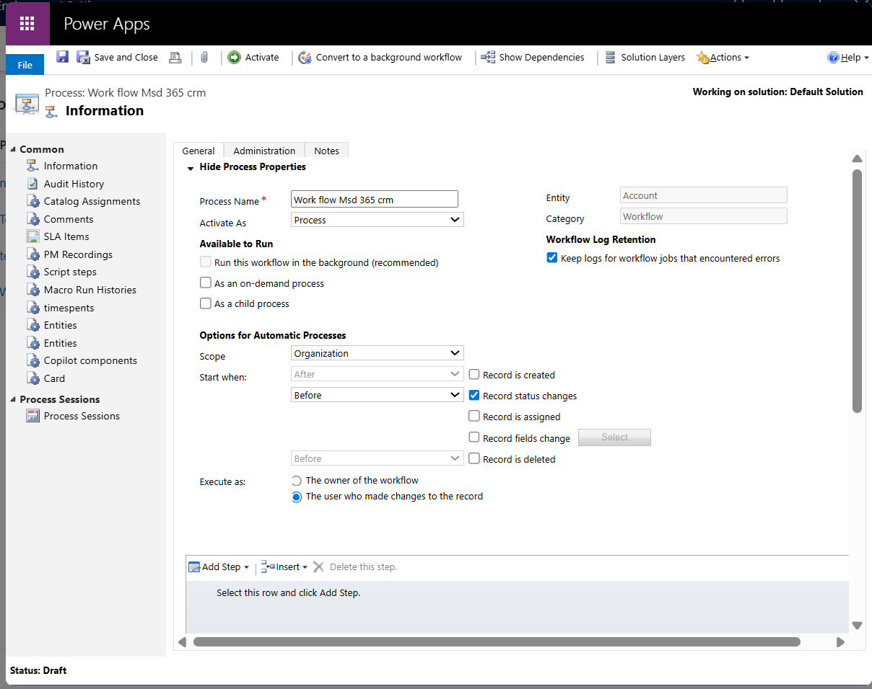

Real-Time Workflow vs Plugin: Execution Order
Like plugins, real-time workflows are executed before (pre-operation) or after (post-operation) the core operation. Both are executed inside the same database transaction.
Here are outlined some actions I have executed to evaluate their execution order:
- Customization of a custom entity named Entity A which contains two text fields named ‘Plugin Text’ and ‘Workflow Text’.
- Registration of two synchronous plugin steps for Pre Update and Post Update, which are triggered when the Entity A name field is updated:
  - Pre Update Event: sets ‘Plugin Text’ with PLUGIN | PRE UPDATE.
  - Post Update Event: sets ‘Plugin Text’ with PLUGIN | POST UPDATE.
- Creation of two real-time workflows; one runs before the update and the other runs after the update. Both are triggered when the Entity A name field is updated:
  - Before Update: sets ‘Workflow Text’ with Workflow | PRE UPDATE.
  - After Update: sets ‘Workflow Text’ with Workflow | POST UPDATE.
Then after created and Entity A record, updated its name to ‘Test update’ and got the following audit.
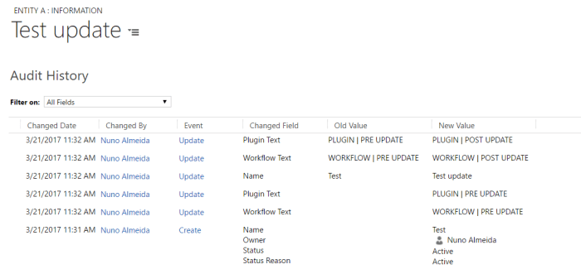
The audit record shows that:
By default: real-time workflows run before than plugins for both pre and post events.
This is explained by the default value of execution order which Plugin Registration Tool sets when registering a plugin step which is equal to one.
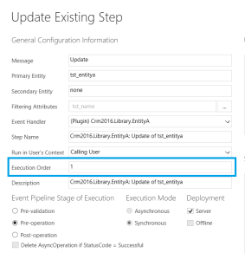
The execution order defined on Plugin Registration Tool set the Rank property of the sdkmessageprocessingstep entity that specifies the processing order within the stage.
https://msdn.microsoft.com/en-us/library/mt622430.aspx
The workflow entity stores the definition of Real-time workflows. The Rank property is not defined when they are created form the Dynamics CRM, although there is the possibility of updating it through SDK.
https://msdn.microsoft.com/en-us/library/mt622427.aspx
If the Rank is not defined, then these events are executed first. If the Rank is defined then events with lower rank are executed first.
Then I updated the execution order (the Rank property) of both plugin steps to zero without updating the Rank of workflows. The audit record shows that the plugins steps run before than workflows.
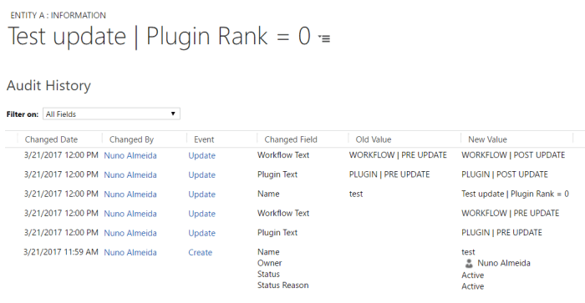
Finally, I set the execution order according to the next table:
Event | Rank
Real-time workflow Pre Update | 0
Plugin Pre Update | 0
Real-time workflow Post Update | 0
Plugin Post Update | 1
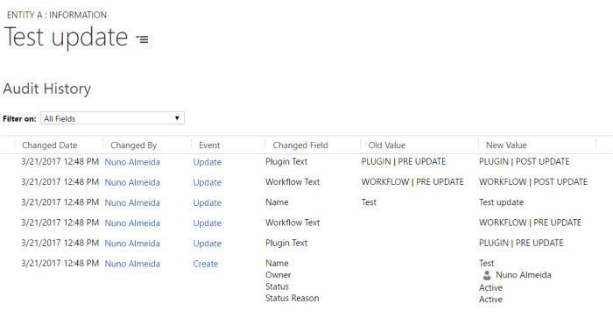
Conclusions:
- By default, real-time workflows are executed before than plugins steps;
- Plugin steps are executed before than real-time workflows when both have set the same rank.

Target
In Microsoft Dynamics 365 CRM plugins, Target is an input parameter (Input Parameters["Target"]) representing the primary entity instance involved in the current data operation (e.g., Create, Update).
It contains the data being sent to the server, allowing developers to validate, modify, or retrieve attribute values during execution.
Data Type: It is typically an Entity object, but for messages like Delete, it can be an Entity Reference.
Usage Context:
  - Pre-Operation: It can be modified before saving onto the database.
  - Post-Operation: It contains the data that has already been saved.

- Target in Create/Update: Usually an Entity object containing the data being created or updated.
- Target in Delete/Assign: The Target is an Entity Reference, which contains only the ID and Logical Name of the record.
- Why EntityReference for Delete/Assign? Delete: The record is being removed, so the system only needs to know the ID (EntityReference) to delete it, not the full field data.
- Assign: The action changes the owner, requiring only the ID of the target record to perform the reassignment.

Why reference for assign –
Assign message is a specialized operation designed to change ownership, not to modify general record data.
Other way to get the id and logical name –
context.PrimaryEntityId and context.PrimaryEntityName

Get the contact Id from the account (Target)-
Use of Entityreference –
Entity entity = (Entity)context.InputParameters["Target"];
// Read lookup field (contactid)
EntityReference contactRef = entity.GetAttributeValue<EntityReference>("contactid");
if (contactRef != null)
{
Guid contactId = contactRef.Id;
}

Sharedvariables use case –
When an Account is updated:
- Pre-Operation plugin computes something (e.g., “old vs new phone changed”).
- It stores the computed results in context.SharedVariables.
- Post-Operation plugin reads that value and performs follow-up logic (e.g., create a note/log record).

Preoperation
context.SharedVariables["PhoneChanged"] = phoneChanged;

Post operation
if (context.SharedVariables.Contains("PhoneChanged"))
{
phoneChanged = (bool)context.SharedVariables["PhoneChanged"];
}
When SharedVariables works
- Works when values are passed within the same operation pipeline (ex: Update request) between steps

❌ When it won’t work
- It won’t persist with the database.
- It won’t be available in a different, later operation (like a separate Update triggered after). SharedVariables is runtime-only in the context
- ✅ Why use SharedVariables?
- Avoid recomputation and repeated Retrieve calls.
- Pass flags / computed values across stages cleanly.

Mini checklist of “interview buzzwords” (quick recall)
- IPlugin, Execute(IServiceProvider) basic structure [learn.microsoft.com]
- IPluginExecutionContext → MessageName, Stage, Mode, Depth, InputParameters, OutputParameters [learn.microsoft.com], [learn.microsoft.com]
- IOrganizationService CRUD methods [learn.microsoft.com]
- ITracingService.Trace() for sandbox logging [learn.microsoft.com]
- Use InvalidPluginExecutionException to fail transaction with friendly message [learn.microsoft.com]
- Plugin registration is done via PRT / VS extension; step + images are configured there

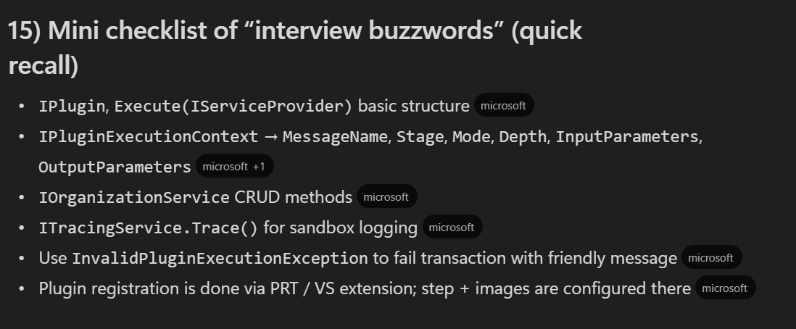
Comparison Table
Operation | Target Type | What it Contains
Create | Entity | Only attributes provided in creation request
Update | Entity | Only modified fields + Id
Delete | EntityReference | LogicalName + Id
Retrieve | EntityReference | LogicalName + Id
RetrieveMultiple | — | No Target
Assign | EntityReference | Record being assigned
SetState / SetStateDynamicEntity | EntityReference | Record whose state is changing
Merge | Entity | Master record

Plugins Notepad notes
Dreamsachiever@1
Topics to be covered
🔹 Fundamentals of Plugins
  - What are plugins in Dynamics 365?
  - Plugin architecture and execution pipeline
  - Plugin registration process
  - Plugin stages: Pre-validation, Pre-operation, Post-operation
  - Plugin modes: Synchronous vs Asynchronous
  - Plugin execution context
🔹 Development Concepts
  - Creating a plugin using C# and .NET
  - Using IPlugin and Iplugin ExecutionContext
  - Accessing Target entity and input/output parameters
  - Working with Organization Service and Service Provider
  - Exception handling in plugins
  - Debugging plugins using Plugin Profiler
🔹 Advanced Plugin Topics
  - Plugin step configuration (message, entity, filtering attributes)
  - Secure and unsecure configuration parameters
  - Plugin images: Pre-image and Post-image
  - Impersonation and user context
  - Performance considerations
  - Plugin depth and recursion handling
🔹 Plugin Registration & Deployment
  - Using Plugin Registration Tool (PRT)
  - Registering plugins manually vs using DevOps pipelines
  - Deploying plugins to different environments
  - Managing plugin assemblies and steps
🔹 Best Practices
  - Keeping plugins lightweight
  - Avoiding hard-coded values
  - Logging and monitoring plugin execution
  - Using shared libraries and helper classes
  - Handling errors gracefully
🔹 Real-World Scenarios
  - Validating data before save
  - Auto-populating fields
  - Creating related records
  - Sending notifications or emails
  - Integrating with external systems

Plugin modes: Synchronous vs Asynchronous

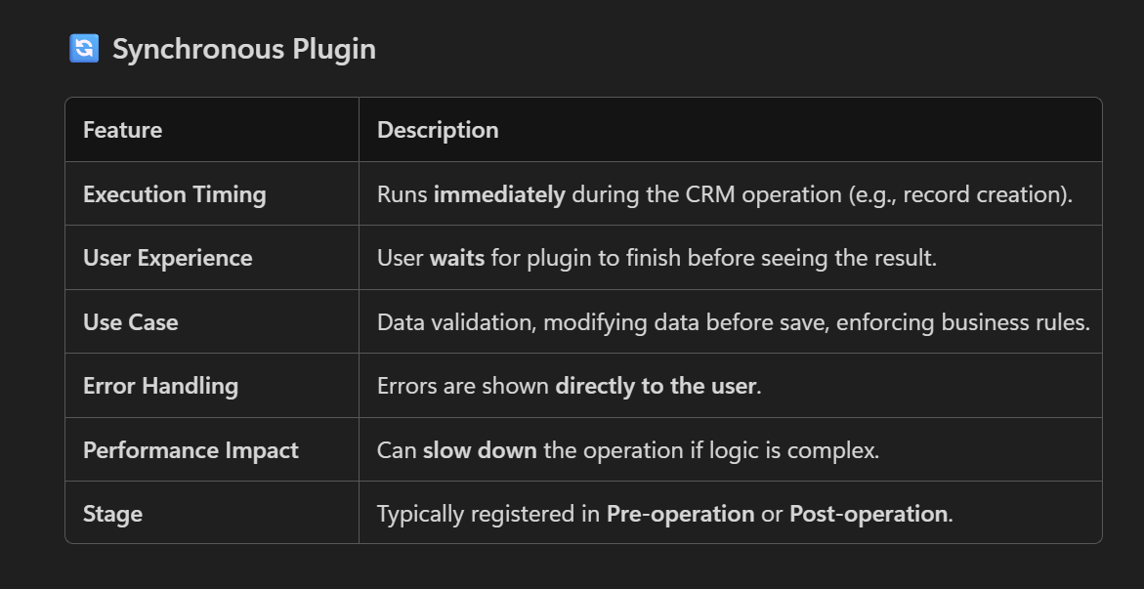

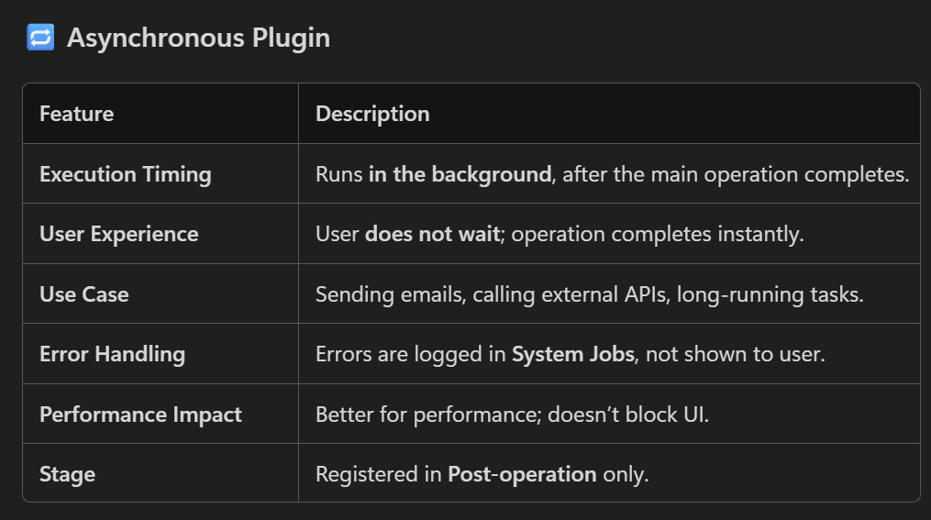

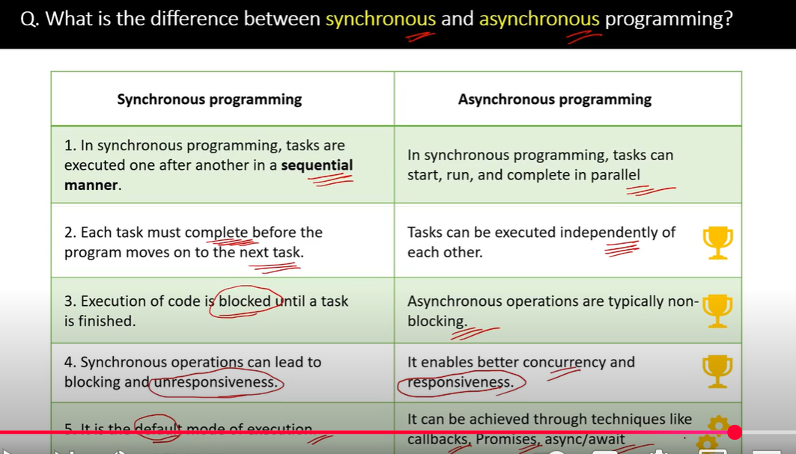

  - Synchronus plugins - tasks are executed one after another in a sequential manner . Each task must complete before procceding to next task. Execution of a code is blocked until a task is finished .
In crm the synchronus plugins are executed immediately . The user waits to complete execution of plugin before seeing the results .
--> synchronus plugins runs in real time , they run immediately as a part of operation they are registered on
--> For instance, if a plugin is registered on the Create event of an entity, it will execute before the record is saved. If something goes wrong , the entire operation fails, and the user receives an error message immediately.

  - Asynchronus plugins - Tasks can be executed parallely , operation is executed in background after the main operation has been completed.
Allows users to continue working without waiting for plugin to finish .
  - Error handling - can't use profiler for debugging or cannot attach a debugger . Have to use the trace logs and system jobs to find asynchronus jobs.
  - Settings > System Jobs
  - The exception message for asynchronous registered plug-ins is written to a System Job table, also known as the AsyncOperation Table.

Profiler - It is used for capturing the context information about the plugin during runtime as well as information that allows for replaying event locally so you can debug.

  - Plugin Profiler is a tool used to capture the execution context of a plugin during runtime. This includes details like:
  - Input/output parameters
  - Entity images (pre/post)
  - Execution pipeline stage
  - Secure/unsecure configuration
  - User context

Replaying an Event means:
Simulating the plugin execution locally using the captured context, so you can debug the plugin code

Execution Context - All the properties of execution context are read only .

Properties of execution context-
  - InputParameters (request parameters), OutputParameters (response results), SharedVariables (data passed between steps), InitiatingUserId (the user causing the event), and MessageName (the name of the web service message)

  - InputParameters, OutputParameters, and SharedVariables are ParameterCollection values. You can manipulate the values of the items in these collections to change the behavior of the operation, depending on the stage in the event execution pipeline your plug-in is registered for.

  - Update Message –

Images
  - Pre-Image:
    - Pre-Image:
    - Contains the values of the entity before the update operation.
    - Useful for comparing old vs new values.
    - You must explicitly register the Pre-Image in the Plugin Registration Tool and specify the attributes you want to capture.
    - Pre-Image will fetch the previous (original) values, not the updated ones.

  - Post-Image:
  - Contains the values of the entity after the update operation, i.e., the new values.
  - Also needs to be registered with the correct name and attributes.

Query Expression
  - Difference between Condition Expression and Filter Expression ?
Ans:
Condition Expression : Represents the single condition on the field.
  - Usage: Used to specify a comparison between a field and a value (or another field).

Filter Expression :
  - Purpose: Represents a group of conditions (i.e., multiple Condition Expression instances).
  - Usage: Used to combine multiple conditions using logical operators like AND or OR.

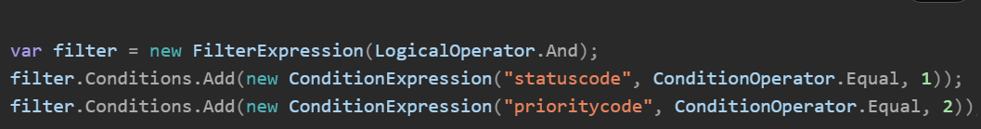

  - What is Iplugin ?
Ans:
  - Base Interface for creating plugins
  - Provided by the Microsoft.Xrm.Sdk namespace that allows developers to write custom business logic that runs in response to specific events in the CRM system.

Method : Void Execute(IServiceProvider serviceProvider)

  - Accessing Target entity and input/output parameters ?
Ans :
  - Input parameters - Contains data passed into the plugin by the CRM platform. They represent the information available to the plugin at the time of its execution.
Key | Message(s) | Description
"Target" | Create, Update | The entity being created or updated (Entityobject).
"EntityMoniker" | Delete, SetState | Reference to the entity (EntityReference) being deleted or whose state is changing.
"State" | SetState | New state value (e.g., Active, Inactive).
"Status" | SetState | New status value.
"Assignee" | Assign | The user or team to assign the record to (EntityReference).
"Principal" | GrantAccess | The user/team being granted access.
"AccessRights" | GrantAccess | The type of access rights (e.g., Read, Write).
"ColumnSet" | Retrieve | Specifies which columns to retrieve.
"Target" | RetrieveMultiple | Query object (e.g., QueryExpression, FetchExpression).

E.g- Context.Inputparameters.Contains("target") && Context.InputParameters["Target"] is Entity entity

  - Output parameters - These are the values or data that the plugin returns as a result of its execution.

"Id" | Create | The GUID of the newly created record.
"BusinessEntity" | Retrieve | The retrieved entity.
"Entities" | RetrieveMultiple | A collection of retrieved entities (EntityCollection).
"Response" | Custom Actions | The response from a custom action.

The OutputParameters are not populated until after the database transaction, so they are only available for plug-ins registered in the PostOperation stage. If you want to change the values returned by the operation, you can modify them within the OutputParameters

- Use of catch if we can directly throw the error using the throw in c#?
Ans :
1. Graceful Error Handling -
You can log the error, show a user-friendly message, or take corrective action.
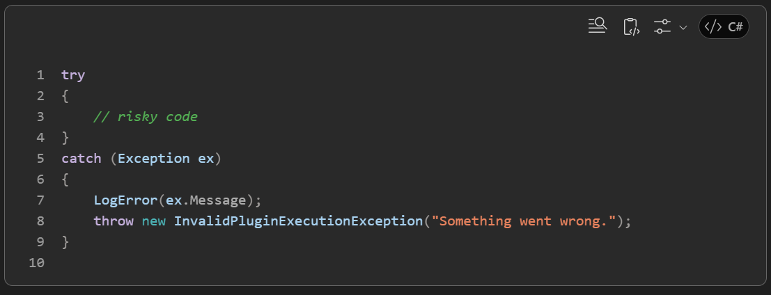

- Custom Exception Messages
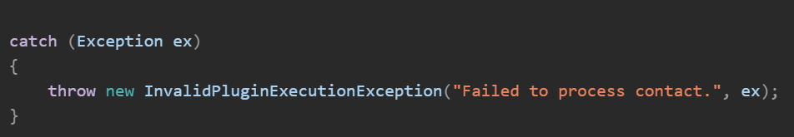

- Selective Handling
You can catch specific exceptions and handle them differently.

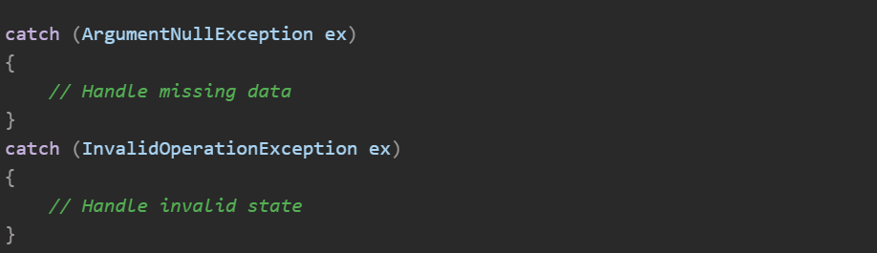

- Avoid Plugin Failure (Optional)
In some cases, you might want to log the error but not fail the plugin.

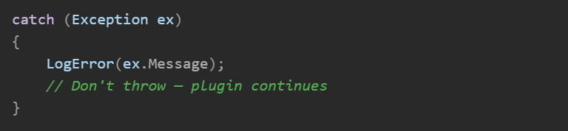

- Use throw when want to immediately fail the execution of plugin and show the error to the user.

  - Execution order and the priority of execution of different stages in msd 365 crm
Ans -
1. Execution Pipeline Stage:-

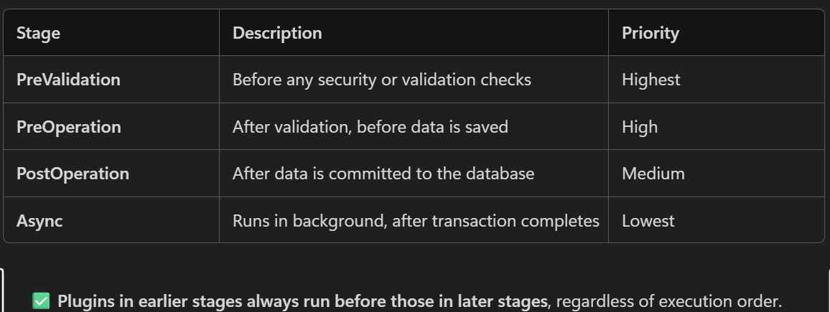

  - 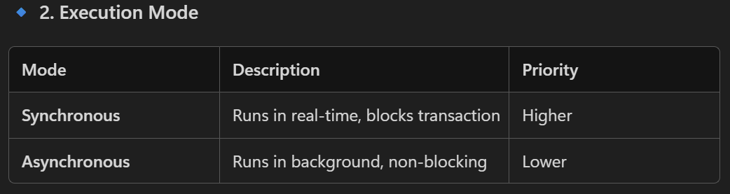

Synchronous plugins run before asynchronous ones

Pre-Validation and Pre-Operation support only Synchronous execution; Post-Operation supports both Synchronous and Asynchronous modes.

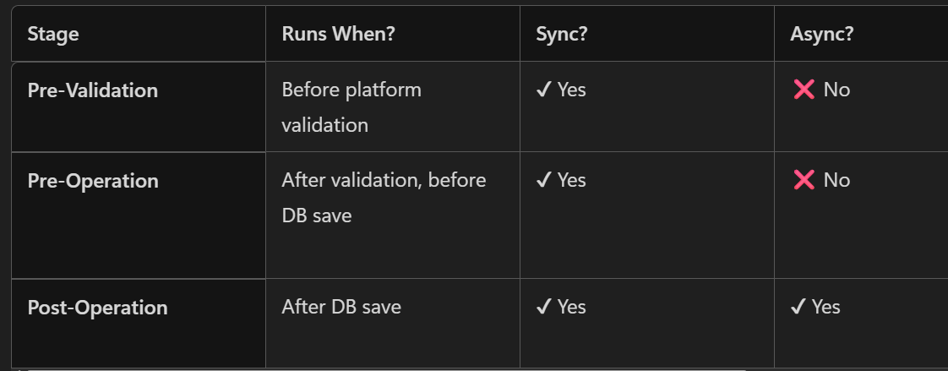

4 . Execution Order (Within Same Stage)
Integer value (e.g., 10, 20, 30)
Lower number = higher priority
Only applies within the same stage and mode
  - Execution Priority = Stage ➜ Mode ➜ Execution Order

E.g =>
Plugin Name | Stage | Mode | Execution Order | Runs First?
ValidateContact | PreValidation | Sync | 20 | ✅ 1st
CalculateDiscount | PreOperation | Sync | 10 | ✅ 2nd
LogOpportunity | PostOperation | Sync | 5 | ✅ 3rd
SendEmail | PostOperation | Async | 1 | ✅ 4th

  - All plugins registered on the same message and entity (for example, "Update" on "Contact") will execute in order of their rank (lowest number first).
  - Secure and Unsecure configuration -
  - Only the users with the admin role can access the secure config whereas the non admin and admin can access the unsecure config
Use case of unsecure config -passing the non-sensitive data like flags, URLs, or feature toggles
Use case of secure config - passing the Sensitive data like API keys, passwords, tokens
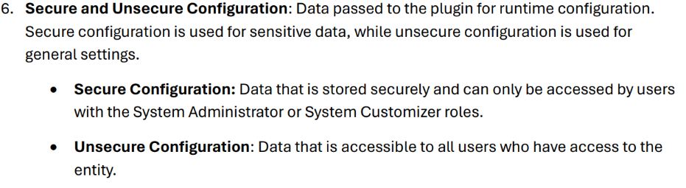
Other Findings -
  - User with having the non admin access to prt e.g - system customizer can't edit the secure and unsecure configurations.
  - PRT can only accessed by system admin and system customizer
  - For accessing the prt other than these role has to give priviledges like

  - 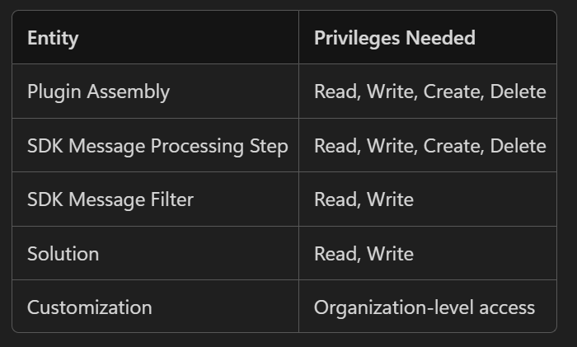

  - These privileges needs to give at security role level
  - Grant Plug-in Privileges: In the security role settings, grant the necessary privileges for managing plug-ins, such as "Create," "Read," "Update," and "Delete" for the "Plug-ins" and "Web Resources" entities.

Difference between Exception and persist to entity –
Persist to Entity is relevant only for async plugins; sync plugins always behave like exception handling with immediate rollback.

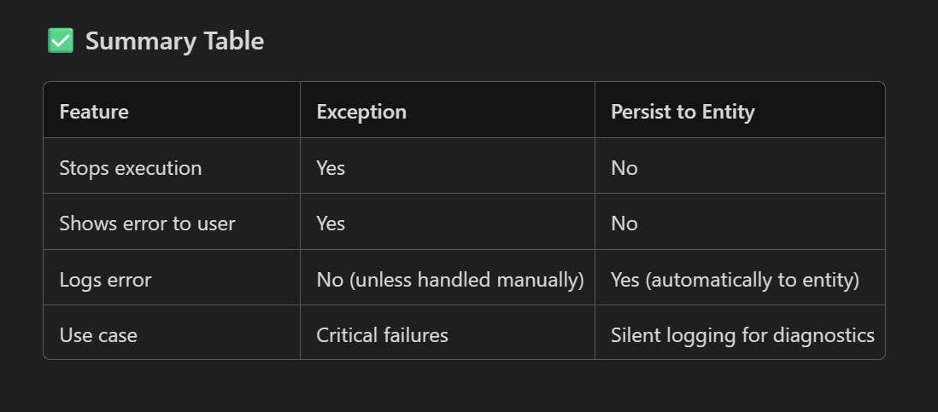
  - Exception

Meaning: This option is used to throw an exception when the plugin encounters an error.
Effect:
The plugin execution fails.
The transaction is rolled back (if it's part of a pipeline).
The user sees an error message in the UI.
Use Case: When you want to stop the operation and notify the user or system that something went wrong.

  - Persist to Entity
Meaning: Instead of throwing an exception, this option logs the error details to a custom entity (usually Plugin Trace Log or a custom error log entity).
Effect:-
The plugin execution continues or fails gracefully.
The error is recorded for later analysis.
No error is shown to the user directly.
Use Case: Useful in non-critical operations or when you want to track errors silently without interrupting the user experience.

  - IExecutionContext.IsInTransaction Property - boolean

  - Gets a value indicating if the plug-in is executing within the database transaction.

Full form of
ISV (Independent Software Vendor) error

  - difference between persist to entity and exception in plugin registration tool in msd 365 crm

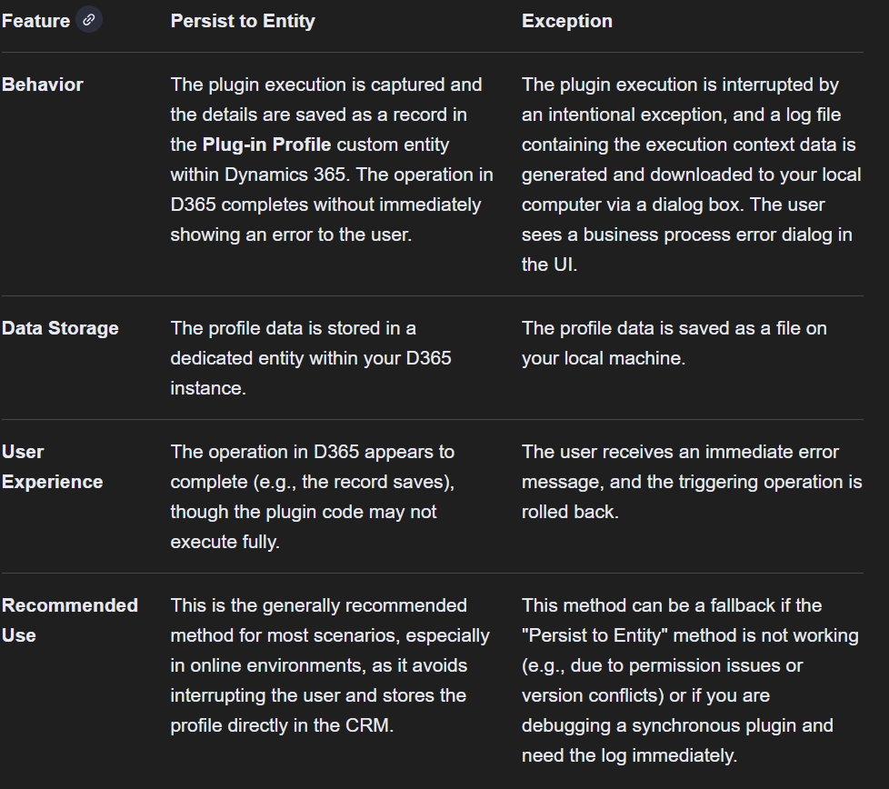

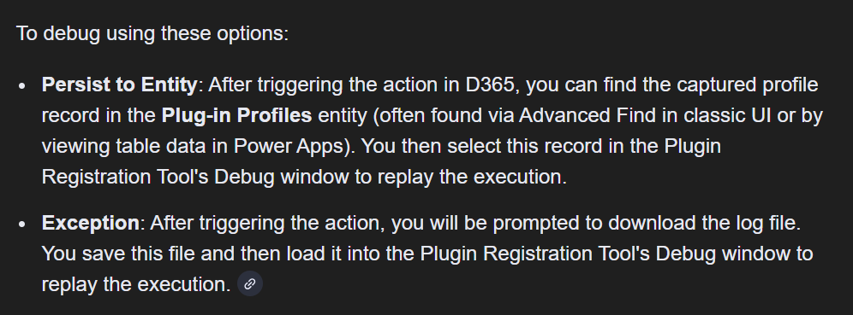

Plugin steps

- Iplugin -Base interface which gives the execute method

- IServiceProvider provides access to service instances that are registered in the application's service container. You request a service by its type, and it returns the corresponding instance.

- 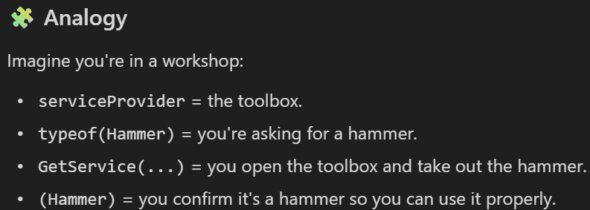

- While Debugging :
Debugger Simulates IServiceProvider

When you load the profile in Visual Studio using the Plugin Registration Tool, the debugger reconstructs a fake IServiceProvider.
This simulated IServiceProvider behaves like the real one — so when your plugin calls:

- What is IOrganizationServiceFactory?
- IOrganizationServiceFactory is an interface provided by Microsoft Dynamics CRM that allows you to create instances of IOrganizationService.

- Think of it like a factory that builds a tool (IOrganizationService) which you use to interact with CRM data — like creating, updating, deleting, or retrieving records.

Database transaction -
What is a DB Transaction?
A DB Transaction (Database Transaction) is a single, atomic unit of work performed by a database where:
✔ Either everything succeeds → commit
✔ Or everything fails → rollback
There is no partial save.
A DB transaction is an “all-or-nothing” operation.
If any step fails, the entire operation is undone (rolled back).

- Then what happens if you throw an exception in Pre-Validation?
✔ The save is stopped before even touching the database
✔ CRM shows error
✔ No data enters the transaction phase
✔ No rollback needed because nothing was written
So the result feels like a rollback, but technically:

The transaction never started.
The operation is cancelled before any DB work.

Operation stages -
1. Pre-Validation Stage
Key Points
Executes before any platform security checks and prior to the creation of the transaction context.

Runs before CRM platform validation.
Runs outside the database transaction.
(Microsoft confirms Pre-Validation runs before security checks and outside the main transaction) [hellosmart.ca]
Used for early validation, permission checks, duplicate checks, blocking logic.
If you throw an exception → CRM stops immediately → record is not saved.
If you do not throw an exception → pipeline continues normally.
Modifying Target here does NOT persist, because CRM rebuilds the Target later.

Conclusion
👉 Pre-Validation = Validate or Block Only
👉 No data modification persists

2. Pre-Operation Stage
Key Points

Runs after validation but before the database write.
Runs inside the DB transaction.
(Microsoft: Pre-Operation plugins execute within the database transaction) [community....namics.com]
This is the correct stage to modify Target.
Any modifications here:
✔ Become part of the final record
✔ Are committed if transaction succeeds
✔ Are rolled back if exception occurs

Conclusion
👉 Pre-Operation = Modify data safely before CRM saves it
👉 Best stage for: defaulting fields, calculations, enforcing business rules, fixing data.

3. Post-Operation Stage
Two variants:
Post-Operation (Synchronous)

Runs after DB operation but still inside transaction.
If exception is thrown → entire transaction is rolled back.

Post-Operation (Asynchronous)

Runs outside the transaction.
Cannot roll back CRM save (record is already committed).

What is Rollback?
Rollback means:

Undoing all the changes made during a database transaction so that the database returns to its previous state.
Nothing gets saved.
It is as if the operation never happened.

- If Pre-Validation is NOT in the DB transaction, then HOW is the data saved?
- Pre-Validation does not save anything to the database because it runs outside the DB transaction. It only validates or blocks the operation.
- The actual data saving happens later, during the Pre-Operation and database commit stage. That’s why modifications made in Pre-Validation do not persist.
- If there is no Pre-Operation step, CRM will save the data normally, but any modifications done in Pre-Validation will NOT be saved because only Pre-Operation runs inside the DB transaction and can persist Target changes.

What happens if you have NO Pre-Operation plugin step at all?
Even though you don’t have a Pre-Operation plugin, CRM still executes the Pre-Operation stage internally.
So:
- The record will be saved
- CRM will commit the data
- No custom pre-save manipulation will happen

2. Any changes made in Pre-Validation will NOT be saved
Because Pre-Validation is outside the DB transaction, and the record is not ready to be persisted yet.
So if you do:

C#target["new_name"] = "ABC";
in Pre-Validation only, then:
❌ It will NOT be persisted
❌ It will NOT reach the database
❌ CRM will ignore it and rebuild Target later
Only Pre-Operation can persist Target changes automatically.

User clicks Save
│
▼
PreValidation
│
▼
Security Check
│
▼
Start Database Transaction
│
▼
PreOperation
│
▼
Database Operation (Create/Update/Delete)
│
▼
PostOperation
│
▼
Commit/Rollback Transaction

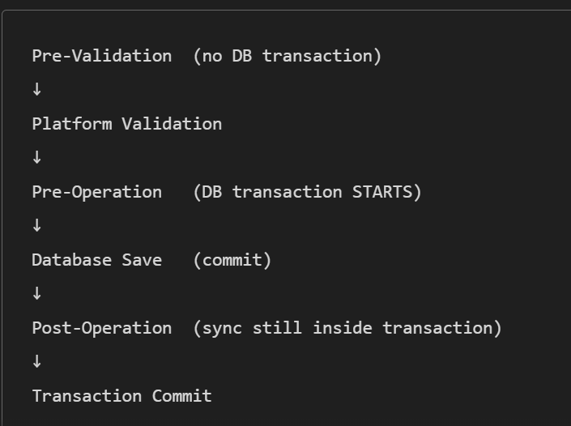

- ENTITY-LEVEL PRIVILEGE CHECK (Highest impact)
Before any plugin runs (except Pre-Validation), Dataverse checks whether the user has:
- Create permission (Create message)
- Write permission (Update message)
- Delete permission (Delete message)
- Assign/Share permission
- Append / Append To permission for relationships

👉 If the user does NOT have entity-level permissions,
the operation is blocked BEFORE the plugin modifies anything.
This is enforced because IExecutionContext carries the UserId, and the system validates whether this user can perform the given action

Use of Prevalidation over the preoperation

What is the use of Pre-Validation if everything can be done in Pre-Operation?
The truth:
Pre-Validation exists for scenarios that Pre-Operation CANNOT handle.
Even though Pre-Operation is more powerful (because it’s in the DB transaction), there are critical situations where ONLY Pre-Validation works.
Below is the exact purpose of Pre-Validation, backed by Microsoft sources.

✅ 1. Pre-Validation runs BEFORE security checks
Microsoft confirms:
“PreValidation executes before any platform security checks.”
[hellosmart.ca]
Why is this useful?
Some operations MUST be blocked before CRM checks user permissions.
Example
You want to block deleting an Account if it has Work Orders.
Plug-in must run before CRM performs cascading delete logic.
Otherwise:
- CRM will delete child records first
- Your plugin never gets a chance
- You lose the child data
ONLY Pre-Validation can stop this early.

✅ 2. Pre-Validation is the ONLY stage where you can safely catch DELETE child references
When a delete happens:
- CRM performs cascade delete before Pre-Operation
- So, in Pre-Operation, child records may already be removed
Therefore:
DELETE prevention must be done in Pre-Validation.
This is one of the BIGGEST reasons Microsoft created this stage.

✅ 3. Pre-Validation happens BEFORE the DB transaction starts
Microsoft:
“PreValidation… outside the main transaction.”
[hellosmart.ca]
Why is this useful?
If you need to do external API calls or heavy checks, you should NOT block the database transaction.
Pre-Operation is inside DB transaction, so:
- Long running calls → hold DB locks
- Risk of deadlocks
- Slow performance for all users
Pre-Validation avoids all that.

✅ 4. Pre-Validation is useful for “Cheap Failure”
If you already know the record must not save, it’s better to stop execution early.
Example
When creating a Work Order:
- Customer must not be inactive
- Required configuration record is missing
- Product is discontinued
Stopping early in Pre-Validation:
✔ Saves resources
✔ Avoids opening DB transaction
✔ Avoids loading security checks
✔ Avoids calling Pre-Operation plugins
✔ Avoids unnecessary processing

✅ 5. Pre-Validation is the only place where the plugin runs EVEN if user lacks permissions
Because security checks have not run yet.
Uses:
- Logging attempts by unauthorized users
- Catching attempted invalid operations
- Preventing operations before CRM blocks them

✅ 6. Pre-Validation is the ONLY place where the plugin runs BEFORE duplicate detection
CRM’s duplicate detection runs AFTER Pre-Validation.
So:
- You can override duplicate detection
- You can apply custom duplicate rules
- You can block earlier

🟦 Summary: Why Pre-Validation Exists (What Pre-Operation CANNOT do)
Requirement | Pre-Validation | Pre-Operation
Block delete before cascade delete | ✔ YES | ❌ No
Run before security checks | ✔ YES | ❌ No
Fail fast / save system processing | ✔ YES | ❌ No
Execute heavy external API calls safely | ✔ YES | ❌ No (blocks transaction)
Custom duplicate detection before CRM’s detection | ✔ YES | ❌ No
Run even if user lacks permissions | ✔ YES | ❌ No
Modify data | ❌ No | ✔ YES
Inside DB transaction | ❌ No | ✔ YES

🎯 Final Interview-Ready Answer
Pre-Validation is used for early validations that must happen before CRM starts any processing — before security checks, duplicate detection, and before the DB transaction begins. It is required for delete prevention, fast failure, heavy external checks, and blocking invalid operations at the earliest point. Pre-Operation cannot do these tasks because it runs later, inside the DB transaction.

Yes, a Pre-Operation plugin WILL modify fields even if the user has no security access to those fields, because plugins run in the server pipeline under the execution context user, not the form user. Field-level security does not apply to plugin execution. Only entity-level privilege failures can block the save.

PreOperation vs Sync PostOperation
Many candidates say:
PreOperation = before commit
PostOperation = after commit
That's technically correct, but the real architectural difference is Modify vs React.

PreOperation
Think:
Record is being built
You can directly modify:
target["field"] = value;
No extra update needed.
Flow:
PreValidation
↓
Security Check
↓
PreOperation
↓
Modify Target
↓
Main Operation
↓
Save Record

Sync PostOperation
Think:
Record already saved
You react to the successful save.
Flow:
Main Operation
↓
Save Record
↓
Sync PostOperation

Biggest Difference #1
PreOperation
Question:
What should the record contain?
Examples:
SLA Assignment
Lead Routing
Pricing Calculation
Customer Classification
Risk Score Calculation
Purpose:
Modify Target

Sync PostOperation
Question:
What should happen because the record was saved?
Examples:
Create Project
Create Child Records
Create Audit Records
Trigger Downstream Processing
Purpose:
React

Biggest Difference #2
PreOperation
target["new_score"] = 100;
Done.
Dataverse automatically saves it.
No service call
No extra database operation
Better performance

Sync PostOperation
Need to update something?
service.Update(entity);
Result:
Additional update operation
Extra database activity
Less efficient for updating same record

Biggest Difference #3
PreOperation
On Update:
Target contains only changed fields
Example:
Name field changed
Target contains:
Name
only.
Need old values?
Use Pre Image

Sync PostOperation
Record already processed.
Available:
Target
Post Image
You can see the final state of the record after save.
Very useful for:
Creating related records
Building audit records
Triggering integrations

Biggest Difference #4
PreOperation
target["status"] = 1;
Result:
No Update call
No recursion risk
``

Sync PostOperation
service.Update(entity);
Can cause:
Update Plugin
↓
Plugin Executes Again
↓
Another Update
↓
Recursion
Prevent using:
if (context.Depth > 1)
{
return;
}

Enterprise Example
PreOperation
Invoice Created
↓
Calculate Tax
Calculate Net Amount
Determine Approval Matrix
Assign Cost Center
↓
Save Invoice Once
Reason:
These values belong on the Invoice record itself.

Sync PostOperation
Invoice Approved
↓
Create Approval History
Create Audit Record
Create ERP Sync Record
↓
Business reacts to approval
Reason:
These actions happen because the Invoice was successfully saved.

Interview One-Liner
PreOperation = Modify and enrich the current record before save.

Sync PostOperation = React to a successful save by creating related records, triggering business processes, or performing downstream actions.

What is EntityMoniker?

EntityMoniker is a property of the SetStateRequest class.
It is of type EntityReference, which means it holds a reference to an entity using its logical name and GUID.
It is used to identify the specific record whose state you want to change.

Target vs service. Update()
Target represents the record currently being processed by Dataverse in the Create or Update request. When you modify fields on the Target entity inside a PreOperation plugin, you are simply changing the data that will be saved as part of the same request, so no additional Update message is generated, no extra database operation occurs, and there is no recursion risk. In contrast, service. Update() explicitly creates a new Update request, which starts a new Dataverse execution pipeline and can trigger the same plugin again, increasing the execution depth and potentially causing recursion. If an exception occurs in a synchronous plugin, both Target changes and any service. Update() operations are rolled back because they participate in the same transaction. As a best practice, use Target when modifying the current record being saved and use service. Update() when you need to update a different record or perform an update after the record has already been committed.
PreOperation:
target[field1"] = 30
✅ Saved automatically

Main operation = saved to db
Post Operation:
target[field1"] = 30
❌ Not saved

Now need:
service. Update()
✅ Saved
-Extra update call after the mainoperation as modifiying target only changes the in-memory Target object after main operation as db save is done in main operation

In PreOperation, modifying Target changes what gets saved. In PostOperation, modifying Target only changes the local object; use service.Update() if you want the database value to change

Deployment
20 May 2025
12:56

Additional Notes by Topic

Deployment and Process Topics
deployment field changes
Associate and deaassociate
Bpf travaersal

Scope -try catch
Global variable- reusability
Parallel actions

Security and Access Topics
SLA's- scenarios - hierarchy security
Access team templates
priviledge
Security roles
Holiday scheduling

Approaches and Solution Strategy
Approaches
Functions - limitations , pros and cons
Bpf - security roles

Solutions - clone ,patch
Security roles
Plugins
Js
PA

General Platform and Integration Topics
Feedback , technology

Lead qualify - noaccounts and contacts
Power point
Sharepoint integration
Excel
Web api

----------------------------------------------------------------------------------------------------------------------

XML and FetchXML
XML

Filter Element : The filter element is crucial for defining conditions to retrieve specific records.

Filter Type | Description
and | All conditions inside the filter must be true (logical AND).
or | At least one condition inside the filter must be true (logical OR).

<link-entity name='md_receivablesitem' from='md_receivablesitemid' to='md_paymentplanitem' alias='aa'>

Linking the receivableitem entity

Entity :md_receivablesitem ,
Field name in md_receivablesitem : md_receivablesitemid
Field name in paymentplanitem entity : md_paymentplanitem

- Here getting the information about the receivable item

- Common FetchXML Operators

Operator | Description | Example Usage
eq | Equals | statuscode = 1
ne | Not equal | statuscode ≠ 1
gt | Greater than | amount > 1000
ge | Greater than or equal | amount ≥ 1000
lt | Less than | amount < 1000
le | Less than or equal | amount ≤ 1000
like | Pattern match (wildcards %) | name LIKE '%Corp%'
not-like | Pattern does not match | name NOT LIKE '%Corp%'
in | Value is in a list | statuscode IN (1, 2, 3)
not-in | Value is not in a list | statuscode NOT IN (4, 5)
null | Value is null | emailaddress IS NULL
not-null | Value is not null | emailaddress IS NOT NULL
between | Value is between two values | amount BETWEEN 1000 AND 5000
not-between | Value is not between two values | amount NOT BETWEEN 1000 AND 5000
on | Date is exactly on a specific day | createdon = '2025-07-29'
on-or-before | Date is on or before a specific day | createdon ≤ '2025-07-29'
on-or-after | Date is on or after a specific day | createdon ≥ '2025-07-29'

Shared Variables
16 July 2025
15:21

Shared variables in Dynamics 365 plugins are essentially global variables that are accessible across all plugin steps and instances.
1. These variables can be used to store data that needs to be shared across different steps of the plugin or across different instances of the same plugin.
- an instance refers to the entire Dynamics 365 environment or organization (e.g., a production instance or a sandbox instance)
- A step, on the other hand, is a specific configuration within a plugin that dictates when and how the plugin code executes in relation to a particular message (like creating, updating, or deleting a record) and within a specific pipeline stage (pre-validation, pre-operation, post-operation.

In the Dynamics 365 or CRM environment, Shared Variables enable the exchange of data between plugins registered for pre-event and post-event stages in the execution pipeline.

Reduce unnecessary calls to the Dynamics 365 organization service and avoid creating additional custom fields solely for data transfer between plugins

Plugins registered on different stages (e.g., Pre-Operation and Post-Operation) for the same message and same entity share the same execution context.

They can share data using Shared Variables.

They are part of the same transaction (especially in synchronous plugins).

✅ Conditions for "Same Execution Context"
Same Message: The plugins are triggered by the same operation (e.g., Create, Update, Delete).
Same Entity: The operation is being performed on the same entity (e.g., Contact, Account).
Same Execution Pipeline: The plugins are part of the same transaction pipeline (e.g., Pre-Operation, Post-Operation).
Same Request: The plugins are triggered by the same user action or system process.
Synchronous Execution : They are executed synchronously (not asynchronously).

Must Explore this website:
https://community.dynamics.com/blogs/post/?postid=39fea86a-989d-ef11-8a6a-6045bdd59694

Packages
24 July 2025
12:58

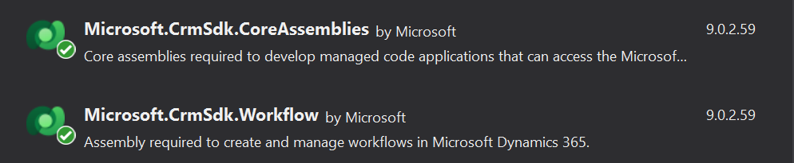



Plugin interview Questions
14 August 2025
14:24

- If you delete a record from UI, what happens in database? Can you bring the record back?OR, what is deletion service? Can you change its schedule?

In Microsoft Dynamics CRM, deleting an entity by using the Web application or through SDK Web service calls usually results in a "soft delete" where the entity is not immediately deleted from the database. Instead, the entity is marked for deletion later. The platform marks the entity for deletion by setting the entity's DeletionStateCode attribute to 2. Entities with a DeletionStateCode attribute set to 2 are filtered out from all data views in the Web application and are not accessible using the SDK.
These marked entities are physically deleted from the database by the Deletion Service. The Deletion Service is an asynchronous operation that is based on a table named ScaleGroupOrganizationMaintenanceJobs in the MSCRM_CONFIG database of Microsoft Dynamics CRM. By default, the frequency of the Deletion Service job execution is set to once a day. You can use the Scale Group Job Editor tool to change the execution frequency of the Deletion Service. You can find the tool on the Web at http://code.msdn.microsoft.com/ScaleGroupJobEditor.

- Synchronus vs Asynchronus
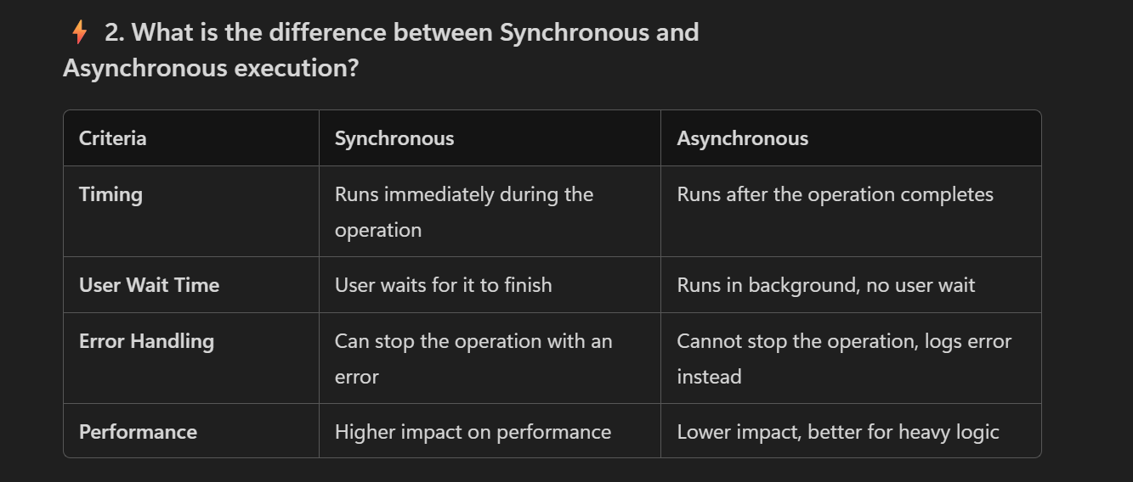

- Plugin Vs Workflow

Plugin :In the Power Platform, a plugin is a piece of code that can be used to extend the functionality of Dynamics 365 and Power Platform applications. Plugins are typically used to perform custom actions or business logic when specific events occur in the system, such as when a record is created or updated.

workflow is a series of automated actions that are triggered by specific events in the system.
Workflows can be used to automate tasks and processes within Dynamics 365 and Power Platform applications, such as sending email notifications, updating records, or triggering other actions.

Plugins are used to perform custom actions or business logic when specific events occur in the system. They are typically used for more complex tasks or actions that cannot be easily accomplished using other tools. Workflows, on the other hand, are used to automate simpler tasks and processes, such as sending email notifications or updating records.

4.for plugin deployment, Difference between GAC, Data Base, Disk deployments.

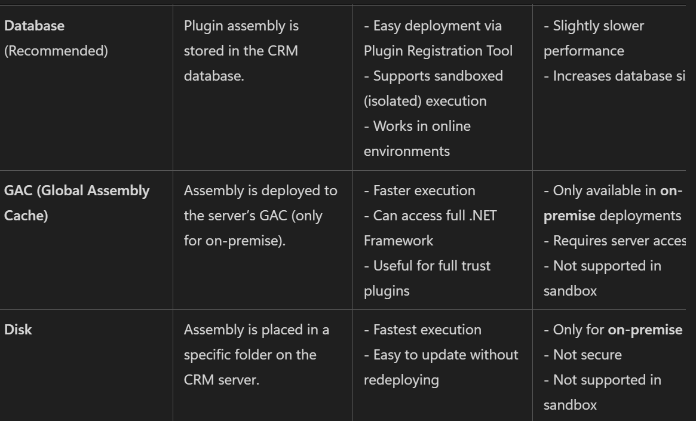

Q. SQL Deadlock
A deadlock in SQL occurs when two or more database transactions permanently block one another because each holds a lock on a resource that the other transaction needs to proceed. Because both transactions are stuck waiting for each other indefinitely, a circular dependency forms, and neither can finish without outside intervention. [1, 2, 3]
A Classic Deadlock Example
Imagine a banking database with an Accounts table. Two users attempt transfers at the exact same time: [1, 2, 3, 4]
┌──────────────────────────────────────────────────────────┐
│ TRANSACTION 1 │
│ 1. Locks Account A (to deduct money) │
│ 2. Tries to access Account B... (Blocked by Trans 2) │
└──────────────────────────┬───────────────────────────────┘
│ ▲
Waits for │ │ Waits for
Account B │ │ Account A
▼ │
┌──────────────────────────────────────────────────────────┐
│ TRANSACTION 2 │
│ 1. Locks Account B (to deduct money) │
│ 2. Tries to access Account A... (Blocked by Trans 1) │
└──────────────────────────────────────────────────────────┘
• Transaction 1 locks Row A and requests a lock on Row B.
• Transaction 2 locks Row B and requests a lock on Row A.
• Result: Neither transaction can complete, creating a standstill. [1, 2, 3]

Q. Database , Disk and GAC-
Database deployment stores the plugin assembly inside Dataverse and is the most commonly used option, especially for Dynamics 365 Online. Disk deployment stores the assembly on the CRM server's file system and requires deployment on every server. GAC deployment installs the assembly in the Global Assembly Cache, requires a strongly signed assembly, and is mainly used in on-premises environments. In modern Dynamics 365 Online implementations, Database deployment is the standard and preferred approach.

Q.What is early binding and late binding?
Early Binding vs Late Binding (D365 CRM Plugins)
Late Binding
Uses the generic Entity class.
Entity account = new Entity("account");
account["name"] = "ABC Corp";
account["telephone1"] = "123456";
string name =
account.GetAttributeValue<string>("name");
Pros
✅ No class generation required✅ Flexible✅ Easy when schema changes frequently
Cons
❌ No IntelliSense❌ Runtime errors due to typos
Example:
account["nmae"] = "ABC Corp";
Compiles successfully ✅Fails at runtime ❌

Early Binding
Uses generated classes like:
Account,Contact,Lead
Example:
Account account = new Account();
account.Name = "ABC Corp";
account.Telephone1 = "123456";
Retrieve:
Account account =
entity.ToEntity<Account>();
string name = account.Name;

Pros
✅ IntelliSense✅ Compile-time validation✅ Strongly typed✅ Easier maintenance
Cons
❌ Need to regenerate classes after schema changes❌ More setup effort

Runtime Error vs Compile-Time Error
Late Binding
account["nmae"] = "ABC";
Show more lines
✅ Code builds❌ Runtime error
Reason:
Plain Text
CRM cannot find attribute 'nmae'

Early Binding
account.Nmae = "ABC";
❌ Compile-time error
Plain Text
'Account' does not contain a definition for 'Nmae'
Show more lines
You catch the mistake before deployment.

How Early Bound Classes Are Generated
Using PAC CLI:
PowerShell
pac modelbuilder build
Show more lines
Generated class:
public partial class Account : Entity
{
[AttributeLogicalName("name")]
public string Name
{
get { return GetAttributeValue<string>("name"); }
set { SetAttributeValue("name", value); }
}
Account account = new Account();
account.Name = "ABC";
account.Telephone1 = "123456";

Same Example Comparison
Late Binding
Entity account = new Entity("account");
account["name"] = "ABC";
Show more lines
Early Binding
Account account = new Account();
account.Name = "ABC";

Interview Answer
Late Binding uses the generic Entity class and fields are accessed using logical names like entity["name"]. It is flexible but errors are detected only at runtime. Early Binding uses generated strongly-typed classes such as Account and Contact, allowing field access through properties like account.Name. It provides IntelliSense and compile-time validation, reducing runtime errors. The main advantage of Early Binding is type safety; the main advantage of Late Binding is flexibility.

Error–
A compile-time error occurs before the code is deployed or executed. In Early Binding, if I use an incorrect property such as account.Nmae, Visual Studio immediately reports an error because the property doesn't exist. A runtime error occurs when the code executes. In Late Binding, if I use an incorrect logical name such as entity["nmae"], the code compiles successfully but may fail at runtime because CRM cannot find that attribute. This compile-time validation is the main advantage of Early Binding.
Q.Isolation Mode in Plugin msd35crm
Sandbox: Runs in a restricted, isolated environment. It is mandatory for Dynamics 365 Online environments and recommended for on-premise. It restricts direct access to local files, the registry, and certain network protocols. Execution is limited to 2 minutes, but plugins can still call external endpoints (like Azure or web services).
None (Full Trust): Removes all security restrictions, allowing your plugin code to access the local file system, network shares, and the registry. This option is only available for Dynamics 365 On-Premises deployments and requires Deployment Administrator privileges to register.
Dynamics CRM On-Premise supports both Sandbox and None (Full Trust) isolation modes. Sandbox provides a secure, restricted execution environment, while None provides unrestricted access to server resources. Dynamics 365 Online supports only Sandbox mode.

5.sequence of how processes trigger sequence wise works in d365 ?
1.Client-side logic (JS, BR) runs before the record is submitted to the server.
2.Synchronous server-side logic (Plugins, Real-time Workflows) runs within the transaction.
3.Asynchronous logic (Async Plugins/Workflows) runs after the transaction is committed.

1)System JavaScript (JS)
2)Custom JavaScript
3)Business Rules (BR)
4)Sync Plugins
5)Sync Workflows
6)Custom Actions
7)Async Plugins
8)Async Workflows

2️⃣ Synchronous Plugins run BEFORE Real-time Workflows
Microsoft documentation:
- Sync plugins run in the pipeline (Pre-Validation → Pre-Operation → Post-Operation). [community....namics.com]
- Real-time workflows also run in the pipeline, but after core operations depending on stage configuration.

6.Asynchronous vs Synchronous

Synchronous Execution

- Timing: Runs immediately during the CRM operation.
- User Experience: The user waits for the plugin/workflow to complete before the operation finishes.
- Use Case: Ideal for real-time validations, calculations, or updates that must happen before the record is saved.
- Error Handling: Errors are shown directly to the user.
- Performance Impact: Can slow down the operation if the logic is complex or takes time.

Asynchronous Execution
Timing: Runs in the background, after the CRM operation completes.

Q.Which will execute first in ASync Workflow and Async Plugin?

Both Async Workflow and Async Plugin run inside the same Asynchronous Service queue, and execution order depends on queue scheduling, system load, and resource availability — not on type.
There is no guaranteed “who runs first” between an asynchronous plug-in and an asynchronous (background) workflow—both are queued and executed by the Dataverse Asynchronous Service when resources are available

EXECUTION ORDER -
It only decides order among plugin steps that are registered on the same entity, same message, and same stage.

LIMITATION OF PLLUGINS -
1.Synchronous Performance Impact: Synchronous plugins run during the user's transaction, so slow plugins directly hurt user experience.

2.Timeouts: A maximum 2-minute limit exists for all plugin execution. It is highly recommended to keep execution under 2 seconds to avoid performance impact

Plugin components
03 September 2025
18:57

  - Workflow Context- Code activity -custom wf
Interface

Metadata-

Namespace:
Microsoft.Xrm.Sdk.Workflow
Assembly:
Microsoft.Xrm.Sdk.Workflow.dll
Package:
Microsoft.CrmSdk.Workflow v9.0.2.59

--> Provides access to the data associated with the process instance.
-->Provides contextual information about the environment when a custom workflow activity has been executed.

-->Used for custom workflow activities

  - RetrieveAttributeRequest Class
  - Contains the data that is needed to retrieve attribute metadata

  - Different properties in Execution context
Property | Description
Message Name | The name of the operation triggering the plugin (e.g., Create, Update, Delete)
Primary Entity Name | Logical name of the entity (e.g., lead, contact)
Primary Entity Id | GUID of the record being processed
Stage | Execution stage (e.g., PreValidation = 10, PreOperation = 20, PostOperation = 40)
Mode of Execution | mode (Synchronous = 0, Asynchronous = 1)
Depth | Indicate how many times the plugin has been triggered recursively
Initiating User Id | The user who initiated the operation
User Id | The user under whose context the plugin is executing
OrganizationId | GUID of the organization
BusinessUnitId | GUID of the business unit
InputParameters | Contains parameters passed to the plugin (e.g., Target)
OutputParameters | Contains output values from the plugin
SharedVariables | Used to pass data between plugins in the same pipeline
PreEntityImages | Snapshot of the entity before the operation (used in Update or Delete)
PostEntityImages | Snapshot of the entity after the operation (used in Create or Update)
IsExecutingOffline | Indicates if the plugin is running in offline mode
IsInTransaction | Indicates if the plugin is part of a transaction
CorrelationId | used for tracking across multiple plugin executions
OperationId | Unique ID for the current operation

  - isnullorempty in c# :

--->String.IsNullOrEmpty() is a static method used to determine if a string is either null or an empty string ("")

Return Value :
--> True if the value parameter is null or an empty string (""); otherwise, false

Authentication for Microsoft Dynamics CRM REST API requests
25 August 2025
12:23

Authentication for Microsoft Dynamics CRM REST API requests primarily relies on OAuth 2.0 and Azure Active Directory (AAD).

1. Authentication:
Register your application in Azure Active Directory (AAD):
This step is crucial to obtain a client_id and potentially a client_secret if using a confidential client application. You will also configure redirect URIs and API permissions, granting your application access to Dynamics 365.

Obtain an access token:
Authorization Code Grant Flow: This is common for client-side applications or web applications where user interaction is involved. It involves redirecting the user to AAD for login and consent, receiving an authorization code, and then exchanging that code for an access token.
Client Credentials Flow: This is suitable for server-to-server (S2S) integrations where no user interaction is required. You use the client_id and client_secret to directly request an access token from AAD.
Include the access token in API requests:
Once obtained, the access token is included in the Authorization header of your HTTP requests to the Dynamics 365 Web API, typically in the format Bearer <access_token>

2. Handling the Response for Successful Data Update:
HTTP Status Codes:
A successful data update (e.g., using a POST for creation or PATCH for update) will typically result in an HTTP status code of 200 OK or 204 No Content for updates, and 201 Created for creations.
Response Body:
For POST requests resulting in a 201 Created, the response body often contains the newly created entity's details, including its unique identifier.
For PATCH requests resulting in a 204 No Content, the response body is typically empty, indicating the update was successful.
For other successful operations like GET (retrieval), the response body will contain the requested data in JSON format.

Error Handling:
Always anticipate and handle potential errors. The Dynamics 365 Web API returns errors in JSON format, providing details about the issue. Parse the response body for error messages and codes to implement appropriate error handling logic in your application.

Alias in plugin
07 September 2025
17:05

- Aliased Value -
- It is an object
- used for unwrapping the attributes or accessing the attributes from the linked entities (if not attributes is not from base attribute)
- E.g:
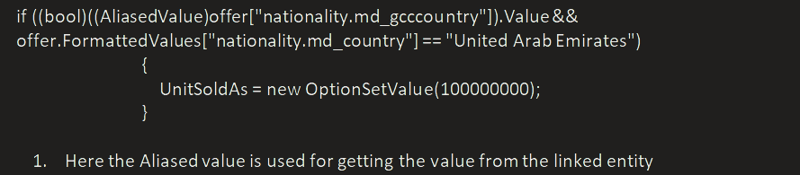

- Formatted values -It’s a dictionary
- Used for string representation of field value e. g labels for option set value.

- ?. -The ?. operator in C# is called the null-conditional operator
- Used to avoid NullReferenceException
- e.g:
var name = person?.Name;
- person is a variable that might be null.
- person?.Name means:
- If person is not null, return person.Name.
- If person is null, return null (instead of throwing a NullReferenceException).
Custom Workflow Activity
11 September 2025
15:32

Custom wf activity is used for extending the functionality of workflow. Due to the limitation of wf like
- WF can't work on related entities
- Can't be used for complex logic

Have to pass the Input properties e.g - > contact(contact)

Refer
For Debugging - https://learn.microsoft.com/en-us/power-apps/developer/data-platform/workflow/debug-workflow-activites

Imp -
1. for profiling use profiler at the end

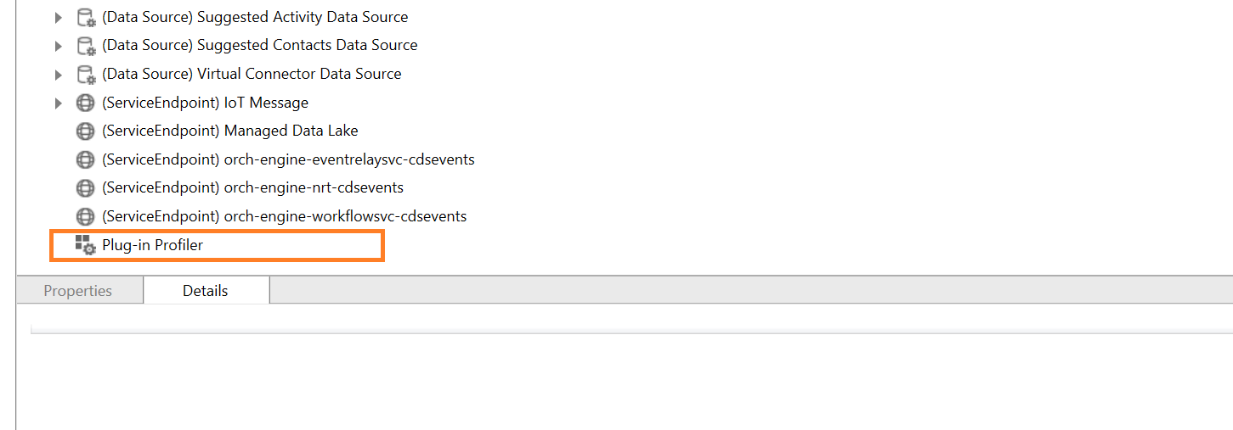

- Multiple assemblies can be profiled at once

- Difference between CWF activity and plugin ?
Ans -

Pass input as
Input("Contact")]

Set output
[Output("Formatted Name")]
Then -->

// Set output argument
FormattedName.Set(executionContext, formatted);

Impersonation using the plugin
22 January 2026
14:22

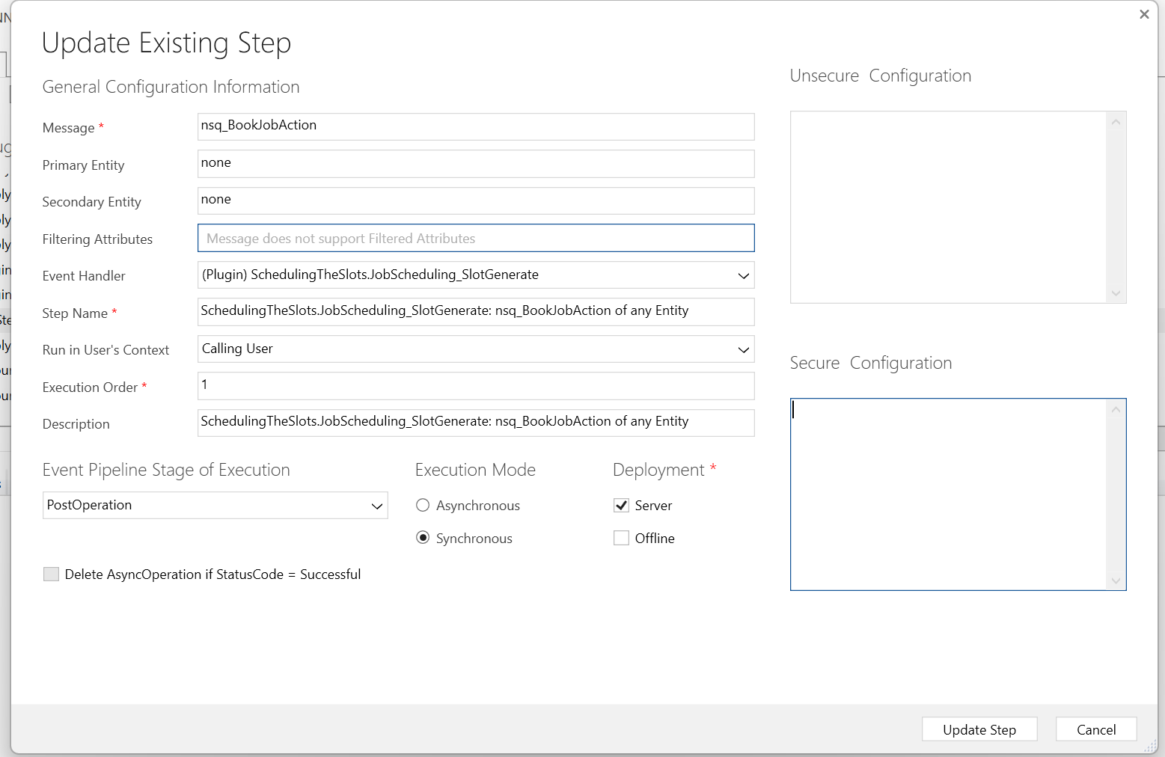

Run in users context -

Scenario (Real-Life)
You have a plugin on Work Order (msdyn_workorder) → Update.
Requirement:

Normal users can update the Work Order.
But whenever Status = Completed, the plugin should create an Invoice.
Many users do not have Create permission on Invoice.
So you want:
✅ Validate using the calling user
✅ Create invoice using a service account (impersonation)

This is a classic impersonation use case.

What would happen WITHOUT impersonation?
Plugin runs as the normal user (calling user).
When plugin tries to create Invoice:
➡️ It fails with: “Insufficient Privileges”
Because user doesn’t have permission to create invoice.

✅ How impersonation fixes it
Inside the plugin:

You read/validate using InitiatingUserId (the real person)
You create the invoice using a service account user id

So invoice creation succeeds (service account has rights).

“In a plugin, impersonation is done by creating an organization service using a different userId through CreateOrganizationService(userId). For example, I validate logic using InitiatingUserId to respect the real user, but I create restricted records like Invoice using a service account userId so the operation doesn’t fail due to insufficient privileges. This also affects auditing because Created By/Modified By will reflect the impersonated user.”

Will have step create of invoice plugin where the user context will be one who can create invoice and then normal user can create the invoice - is it
correct

“Invoice creation is a financial operation and cannot be given to all users due to security, compliance, and data visibility concerns. But some business workflows require automated invoice creation. So we register a plugin on ‘Invoice – Create’ and set the step to run under a privileged user. This means even if a normal user triggers the action, CRM validates permissions using the privileged user’s security context, allowing controlled and secure invoice creation without exposing financial permissions to everyone.”

Questions
23 January 2026
16:49

- How to get the security role of user in msd 365 crm
-----> use role table and link entity

Using the javascript -
var roles = Xrm.Utility.getGlobalContext().userSettings.roles;

Using the plugin

// Assuming you have IOrganizationService service and Guid userId
QueryExpression query = new QueryExpression("systemuserroles");
query.ColumnSet = new ColumnSet("roleid");
query.Criteria.AddCondition("systemuserid", ConditionOperator.Equal, userId);

EntityCollection userRoles = service.RetrieveMultiple(query);

List<Guid> roleIds = new List<Guid>();
foreach (Entity entity in userRoles.Entities)
{
roleIds.Add((Guid)entity["roleid"]);
}

// Now you can query the 'role' entity using these IDs to get name
Plugin Interview Questions
09 February 2026
16:05
- Difference between Entity and Entity Reference in plugin?
Ans - Entity represents a full record object (or a partial record) that contains:
- Logical name (table name)
- Record Id (GUID)
- Attributes (columns) in a key/value dictionary (Attributes)
- Formatted values, related entities, etc.

In plugins, you mostly get Entity as Target for:
- Create
- Update

- EntityReference is a pointer/reference to a record.
It contains only:

Logical name (table name)
Id (GUID)

EntityReference as Target for:
- Delete (Target is usually EntityReference)
- SetState / SetStateDynamicEntity
- Associate / Disassociate

if(context.InputParameters["Target"]
context.InputParameters["Target"] is EntityRefrence targetref) {
Guid id = target.Id;
string name = targetref.LogicalName;
}
}

- Message Name - Associate and deassociate =>

Target = EntityReference (not Entity)
It is the primary entity of the association.

You are associating a Contact to an Account:
- Target = Account (EntityReference)
- RelatedEntities = Contact(s) (EntityReferenceCollection)
- Relationship = name of relationship (e.g., "contact_customer_accounts")
Code
try
{
tracingService.Trace("start plugin execution: {0}", this.GetType().FullName);
if (context.InputParameters.Contains("Target") && context.InputParameters["Target"] is EntityReference && context.ParentContext == null)
{
tracingService.Trace("Parent Context is null");
if (context.MessageName == "Associate")
{
if(context.InputParameters.Contains("Relationship") &&
((Relationship)context.InputParameters["Relationship"]).SchemaName.Equals("schemaname"))
{
tracingService.Trace("Relationship Found");
if (context.InputParameters.Contains("RelatedEntities") && context.InputParameters["RelatedEntities"] is EntityReferenceCollection)
{
var primaryEntity= (EntityReference)context.InputParameters["Target"];
var relatedEntities= context.InputParameters["RelatedEntities"] as EntityReferenceCollection
Many To Many relationships

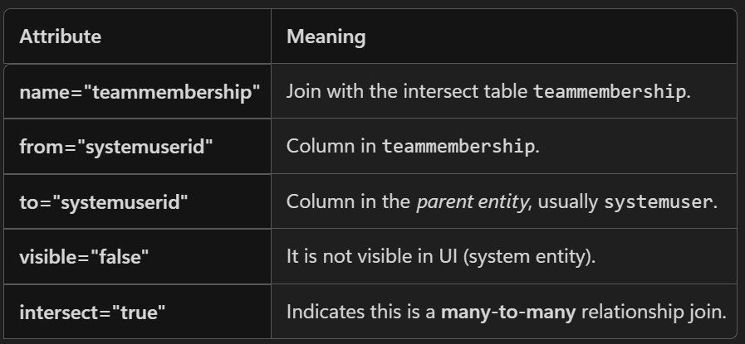
Plugin - Technical Interview Questions
03 September 2025
10:54
- Can you explain how you would authenticate a request to the Dynamics 365 CRM REST API and handle the response for a successful data update?
Ans:
- To authenticate a request to the Dynamics 365 CRM REST API, I would use OAuth 2.0 via Azure Active Directory.
- First, I’d register an application in Azure AD and obtain the Client ID, Tenant ID, and Client Secret. Then, I’d request an access token by making a POST request to the Microsoft identity platform token endpoint, passing the required credentials and scope for Dynamics CRM.
- Once I have the access token, I include it in the Authorization header of my HTTP request to the d365 CRM Web API. For a data update, I’d use a PATCH request to the appropriate entity endpoint.
- 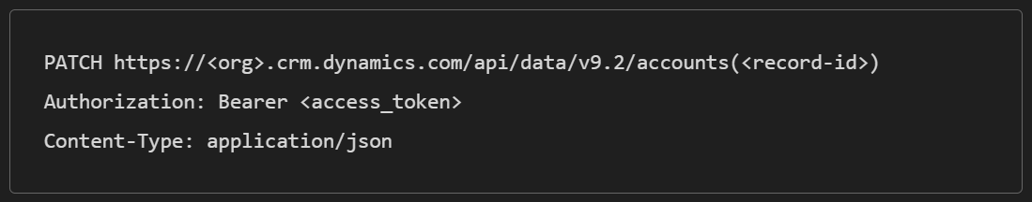
- If the update is successful, the API returns a 204 No Content response, indicating the operation was completed without errors.
Success Response:
Status Code: 204 No Content

- Error Handling:
401 Unauthorized → Token issue
403 Forbidden → Permissions issue
404 Not Found → Wrong entity or GUID
--------------------------------------------------------------------------------------------------------------------------------------------------------------------------------------------------------
Authenticating a request to the Dynamics 365 CRM REST API involves using OAuth 2.0 with Azure Active Directory (Azure AD).
Handling Successful Data Update Responses:

When performing a data update using the Dynamics 365 Web API (typically via an HTTP PATCH request), a successful response indicates that the data has been modified.

Step 1: Register an App in Azure AD
Note down:
Client ID
Tenant ID
Client Secret (create under "Certificates & Secrets")

Step 2: Acquire Access Token
Use a POST request to the Azure AD token endpoint:

Step 3: Send PATCH Request to Update Data
Step 4: Handle the Response
🔧 Success Response:
Status Code: 204 No Content
This means the update was successful.
🔧
--------------------------------------------------------------------------------------------------------------------------------------

- What is the purpose of the $filter OData query option in the REST API for Dynamics 365 CRM?

$filter: Limits the data returned based on specified conditions. It helps you narrow down results and avoid fetching unnecessary data.
-->Reports that return large data sets can be difficult to use and can cause performance problems. To limit the data that is presented in a report, use data filters.

Examples of $filter Usage
🔹 1. Filter by Field Value

--------------------------------------------------------------------------------------------------------------------------------------

- Explain how the $expand OData query Option is utilized in the Dynamics 365 CRM REST API.

-->Purpose of $expand in Dynamics 365 CRM Web API
The $expand query option is used to retrieve related entity data in a single API call. It allows you to include data from lookup or navigation properties (i.e., relationships between entities) without making separate requests.

Why Use $expand?
Reduce API calls by fetching parent/child data together.
Improve performance and simplify logic.
Access related entity fields directly in the response.

Example Use Cases
🔹 1. Expand a Lookup Field (e.g., Account → Primary Contact)
GET /api/data/v9.2/accounts?$expand = primarycontactid

Select Specific Fields from Expanded Entity-

GET /api/data/v9.2/accounts?$expand = primarycontactid($select=fullname,emailaddress1)
Returns only full name and emailaddress1 from the related contact

---------------------------------------------------------------------------------------------------------------------------

Q. use of $select in OData queries within Dynamics 365 CRM REST API.
The $select query option is used to specify exactly which fields (columns) you want to retrieve from an entity. It helps you optimize performance by reducing the amount of data returned in the response.
e.g -
GET /api/data/v9.2/accounts?$select=name,telephone1

--------------------------------------------------------------------------------------------------------------------------------

- Can you explain how the $select option can be combined with $filter in an OData query to
refine the results further?
$filter: Narrows down the records based on conditions.
$select: Limits the fields returned for those filtered records.

-->When you use $expand alone, it pulls all related records, which can be very inefficient for large datasets. By adding $filter inside the $expand, you can limit the related records to only those that meet specific criteria.

GET [Organization URI]/api/data/v9.2/accounts?$expand=contacts($filter=statecode eq 0)

--------------------------------------------------------------------------------------------------------------------------------

Q. What are some common error-handling strategies when using Power Automate in Dynamics 365 CRM?

--> 1. Configure Run After
“Configure Run After” feature use to handle failures, timeouts, or skipped actions.

2. Scope + Parallel Branches
Wrap critical actions inside a Scope and use parallel branches for:

Success path
Failure path

3.Try-Catch Pattern
Simulate a try-catch using:

Scope 1: Main logic
Scope 2: Error handling (runs if Scope 1 fails)
Use “Configure Run After” on Scope 2 to trigger only on failure

4. Terminate Action
Use the Terminate action to explicitly end the flow with:

Succeeded
Failed
Cancelled

5.

6. Use Expressions to Handle Nulls
Avoid runtime errors by checking for nulls:

7. Retry Policy
In Power Automate, a retry policy is a built-in mechanism that automatically retries an action if it fails due to transient errors — like network issues, service timeouts, or temporary unavailability of a connector.

You can configure:

Number of retries
Interval between retries
Timeout duration

Q : Can you explain how you would use the error handling capabilities in Scope Actions to manage exceptions effectively in a Power Automate Flow
Ans : -
Purpose of Scope in Error Handling -
A Scope groups multiple actions together and allows you to:

Monitor the success or failure of all actions inside it.
Handle errors in a clean, centralized way.
Create separate paths for success and failure.
🔁 How to Use Scope for Error Handling
🔹 Step 1: Create Two Scopes
Scope 1: Try block — contains your main logic (e.g., create/update records).
Scope 2: Catch block — handles errors (e.g., send email, log error).
🔹 Step 2: Configure Run After on Scope 2
Click the three dots on Scope 2 → Configure Run After
Enable:
has failed
has timed out
has been skipped
This ensures Scope 2 runs only if Scope 1 fails.

🔹 Step 3: Add Error Handling Actions in Scope 2
Examples:

Send an email to admin
Log error to Dataverse or SharePoint
Terminate flow with custom message

Q. List some advantages of using Power Automate in Dynamics 365 CRM.
1. Seamless Integration with Dynamics 365
2. Low-Code Automation
3. Wide Range of Connectors
Connect Dynamics 365 with:
SharePoint
Outlook
Teams
Excel
SQL Server
Third-party apps (e.g., Salesforce, Dropbox)

4. Real-Time and Scheduled Automation
Trigger flows instantly on data changes .
Run scheduled jobs (e.g., nightly cleanups, reminders).

5. Supports Complex Logic
Use conditions, loops, variables, scopes, and expressions.
Can simulate advanced logic like try-catch, branching, and filtering.

6.supports error handling

Q. how to debug in power automate
==>

Use Flow Run History
check
Which actions succeeded or failed.
Input and output data for each step.
Error messages and status codes.

- How does the 'depth' property affect plugin execution in Dynamics 365 CRM?
Ans :
The Depth property indicates how many times the plugin has been triggered recursively during a single operation or transaction.
Depth = 1: The plugin is executing for the first time in the current operation.
Depth > 1: The plugin has been triggered again due to actions performed by another plugin or workflow within the same transaction.

Used for -
- Prevent Infinite Loops

- Error handling in javascript -
Ans :
try...catch Block
Used to catch exceptions during runtime.
try {
// Code that might throw an error
let result = riskyOperation();
console.log(result);
} catch (error) {
// Handle the error
console.error("An error occurred:", error.message);
}

2. finally Block
Executes regardless of whether an error occurred.

try {
performTask();
} catch (error) {
console.error("Error:", error);
} finally {
console.log("Cleanup or final steps go here.");
}

3. Throwing Custom Errors
You can throw your own errors using throw.
E.g->
function validateAge(age) {
if (age < 18) {
throw new Error("Age must be 18 or older.");
}
return true;
}

try {
validateAge(16);
} catch (error) {
console.error(error.message);
}

4. Handling Errors in Async Code
Use try...catch inside async functions or .catch() with Promises.
Or with Promises:

- Can you explain one advantage of using JavaScript in Dynamics 365 CRM?
Ans- Real-Time Form Customization and User Experience Enhancement
Uses -
Show/hide fields based on user input
Enable/disable controls depending on conditions
Auto-fill values to reduce manual entry
Validate data before saving
Trigger business logic instantly (e.g., calculate discounts)

  - In Dynamics 365 CRM, what happens if a plugin fails during the 'Update' message?
Ans :
  - Synchronous Plugins:
  - Error Display:
If a synchronous plugin throws an Invalid Plugin Execution Exception, an error dialog box is immediately displayed to the user in the Dynamics 365 user interface, providing the message specified in the exception.
  - Transaction Rollback :
The entire transaction, including the 'Update' operation that triggered the plugin, is rolled back. This means any changes made by the user or by other synchronous plugins within the same transaction are undone, and the record is not updated in the database.
2. Asynchronous Plugins:
  - System Job Creation:
If an asynchronous plugin throws an exception, the error is logged and added to the System Job table (also known as the Async Operation table) .
  - No User Interface Impact :
No error dialog is displayed to the user directly within the Dynamics 365 interface at the time of the failure. The user's 'Update' operation completes successfully from their perspective, as the plugin runs in the background.

  - Monitoring and Debugging:
Administrators or developers can monitor the System Job table to identify and debug the failed asynchronous plugin executions.

  - In summary:
  - Synchronous plugin failure:
Blocks the 'Update' operation, displays an error to the user, and rolls back the transaction.
  - Asynchronous plugin failure:
Allows the 'Update' operation to complete, but logs the error in the System Job table for later review and troubleshooting.
  - Does not roll back the operation - Only plugin logic fails.

  - Execution and rollback of plugin on failure of operation in different stages :

Scenario | Plugin Stage | Mode | Core Operation Executes? | Plugin After This Executes? | Rollback?
1 | PreValidation | Sync | ❌ No | ❌ No | No
2 | PreValidation | Async | ✅ Yes | ✅ Yes | ❌ No
3 | PreOperation | Sync | ❌ No | ❌ No | ✅ Yes
4 | PreOperation | Async | ✅ Yes | ✅ Yes | ❌ No
5 | Core Fails | Any | ❌ No | ❌ No | ✅ Yes
6 | PostOperation | Sync | ✅ Yes | ❌ Plugin fails | ❌ No
7 | PostOperation | Async | ✅ Yes | ❌ Plugin fails | ❌ No

- What is the role of pipeline stages in Dynamics 365 CRM plugins and how do they affect
plugin execution ?
=>
How Pipeline Stages Affect Plugin Execution
Transaction Scope: Pre-Operation and Post-Operation stages are part of the transaction. If something fails, changes can be rolled back.
Data Availability: In Post-Operation, you have access to the final data, including the record ID (for newly created records).
Performance: Pre-Validation is faster and safer for lightweight checks since it runs outside the transaction.
Error Handling: Errors in Pre-Validation won’t roll back the operation, while errors in Pre/Post-Operation will.

- Can you explain how to manage transactions in a delete plugin to ensure data integrity, especially when dealing with related entities?
Ans -
Goals of Transaction Management in Delete Plugins
Prevent deletion if related records exist.
Ensure referential integrity across entities.
Log or clean up related data safely.
Avoid partial operations that leave the system in an inconsistent state.

Use Pre-Operation Stage
This allows you to:
Access the record before it's deleted
Validate whether deletion is allowed
Cancel the operation if needed

- Can you explain how you would design a custom error message for users in a
synchronous plugin, and what considerations you would make for different user roles?
Ans-
1. Clarity Based on Role
End Users: Use simple, clear messages.

"Please enter a valid phone number."

Admins or Power Users: Include more technical context.

"Phone number validation failed. Expected format: +91-XXXXXXXXXX."
Q.Which will execute first in Async Workflow and Async Plugin?
There is no guaranteed execution order between an Asynchronous Workflow and an Asynchronous Plugin registered on the same event. Both are placed into the asynchronous processing queue (System Jobs), and the Async Service decides when to execute them.
Q. How can we call external web service in on-premises and Online plugin CRM?
HttpClient client = new HttpClient();

HttpResponseMessage response =
client.GetAsync("https://api.contoso.com/customer")
.Result;

string result =
response.Content.ReadAsStringAsync().Result;

Q.What are the different storage locations available to store a plugin?
Dynamics CRM supports three plugin storage locations: Database, Disk, and GAC. Database is the most commonly used option and the only one supported in Dynamics 365 Online. Disk and GAC are available only in On-Premise deployments and require server access. GAC stores assemblies in the Global Assembly Cache, while Disk stores them in the CRM server file system.

Advantages of Plugins
- Automation of Business Logic
- Plugins allow you to automate complex business rules and processes that go beyond what workflows or Power Automate can handle.

Real-Time Execution
Synchronous plugins run immediately during the operation (e.g., create, update, delete), allowing you to:

Validate data
Modify values
Show error messages to users

e.g - Prevent saving a contact without an email address.

All General Questions and answers
27 January 2026
00:42

  - Signing in use for plugin
Ans -
Signing the assembly is used to give the plugin DLL a strong name, ensuring uniqueness, security, and trust when registering and executing plugins in Dynamics 365 CRM.

2. Why Do We Sign a Plugin Assembly? (Key Interview Points)
Ans - Strong Naming & Uniqueness
  - Signing generates:
    - Version
    - Culture
    - Public Key Token
  - This guarantees no two assemblies with the same name can conflict
  - CRM uses this identity to track and manage plugin assemblies

  - Plugins registered in Sandbox isolation must be signed
  - CRM does not allow unsigned assemblies in sandbox

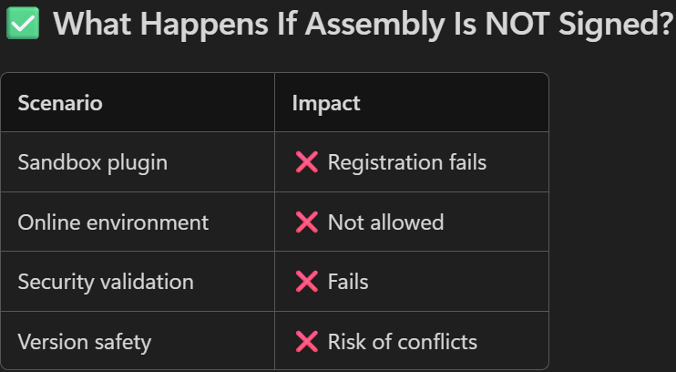

Plugin scenarios
24 July 2025
17:39

Pattern -
1.Brief of scenario/ Business Context-
2.Tools & Features Used - plugins - for business logic , workflow for automation
3.step-by-step process
4.

Business logic
Implementation how using plugin /workflow ?

1.Auto assignment of lead
-->Scenarios based on country
-->Schedular role
-->Access management after reassigning the lead from TSA to PA
-->Role of Workflow

2.Duplicate detection of Lead records
-->Duplicate detection rules
-->Lead to lead check
-->Lead to contact check

-->Duplicate Multiple registration -
-->Duplicate records

3.Batch processing
-->

3.Security roles and access management
-->

Plugin Namespaces And their uses
    - using System.
- Use cases
  - Exceptions (InvalidPluginExecutionException)
  - Basic types (string, DateTime, Guid, TimeSpan)
  - Formatting and parsing (Convert, Guid.Parse)
- Example
JSON
throw new InvalidPluginExecutionException("Validation failed.");

using System.Collections.Generic;
Collections and generic types.
- Use cases
  - Lists for accumulating Entity or IDs
  - Dictionaries for mapping (e.g., option set to text)
  - Passing parameter lists to requests

3. using System.Linq;
LINQ operations on in-memory collections (not FetchXML).
- Use cases
  - Filter/sort in-memory results from a query
  - Transform collections from EntityCollection.Entities
- Example
var contactIds = results.Entities
.Where(e => e.GetAttributeValue<bool>("new_isactive"))
.Select(e => e.Id)
.ToList();

4. using Microsoft.Xrm.Sdk;
Core Dataverse SDK types for plugins.
- Use cases
  - Access IPluginExecutionContext, IOrganizationServiceFactory, IOrganizationService
  - Work with Entity, EntityReference, OptionSetValue, Money
  - Read/Write attributes, create/update/delete records
  - Tracing (ITracingService)

5. using Microsoft.Xrm.Sdk.Query;
Query constructs for Dataverse reads.
- Use cases
  - Build QueryExpression, ColumnSet, FilterExpression, ConditionExpression
  - Paging with PageInfo
  - Link related tables (LinkEntity)

6. using Microsoft.Crm.Sdk.Messages;

    - UtcTimeFromLocalTimeRequest
Use cases
- Assigning records (AssignRequest)
- Set state/status (SetStateRequest, SetStateResponse) — for legacy; in modern, use UpdateRequest with statecode/statuscode where applicable.
7. using Newtonsoft.Json; (Json.NET)
JSON serialization/deserialization (very common for integration scenarios).
- Use cases
  - Serialize attributes to JSON (audit, outbound integration)

Batch processing
01 August 2025
15:37

  - fetchRecords: The base FetchXML query as a string.
  - pagingCookie: A token returned from the previous page fetch, used to continue fetching from where the last page ended.

--> Separation of concerns: One XML creation is for batch processing (retrieving and grouping records), and the other is for payment plan item creation (likely using the same data but for a different operation).

--->
private string GetoptionsetText(string entityName, string attributeName, int optionSetValue, IOrganizationService service)
{
string AttributeName = attributeName;
string EntityLogicalName = entityName;
RetrieveEntityRequest retrieveDetails = new RetrieveEntityRequest
{
EntityFilters = EntityFilters.All,
LogicalName = EntityLogicalName
};
RetrieveEntityResponse retrieveEntityResponseObj = (RetrieveEntityResponse)service.Execute(retrieveDetails);
Microsoft.Xrm.Sdk.Metadata.EntityMetadata metadata = retrieveEntityResponseObj.EntityMetadata;
Microsoft.Xrm.Sdk.Metadata.PicklistAttributeMetadata picklistMetadata = metadata.Attributes.FirstOrDefault(attribute => String.Equals

(attribute.LogicalName, attributeName, StringComparison.OrdinalIgnoreCase)) as Microsoft.Xrm.Sdk.Metadata.PicklistAttributeMetadata;
Microsoft.Xrm.Sdk.Metadata.OptionSetMetadata options = picklistMetadata.OptionSet;
IList<OptionMetadata> OptionsList = (from o in options.Options
where o.Value.Value == optionSetValue
select o).ToList();
string optionsetLabel = (OptionsList.First()).Label.UserLocalizedLabel.Label;
return optionsetLabel;
}

Environment variable
18 February 2026
16:21

- Entities: Environment variables are stored in two tables: environmentvariabledefinition (stores the schema name, data type, and default value) and environmentvariablevalue (stores the current/overridden value).

private string GetEnvironmentVariable(IOrganizationService svc, string schemaName)
{
// 1) Try to find current value (environmentvariablevalue joined to definition by schema name)
var q = new QueryExpression("environmentvariablevalue")
{
ColumnSet = new ColumnSet("value"),
TopCount = 1
};

q.AddLink("environmentvariabledefinition", "environmentvariabledefinitionid", "environmentvariabledefinitionid")
.LinkCriteria.AddCondition("schemaname", ConditionOperator.Equal, schemaName);
var current = svc.RetrieveMultiple(q).Entities.FirstOrDefault();
if (current != null && current.Contains("value") && current["value"] != null)
return (string)current["value"];
// 2) Fallback: read defaultvalue from definition

var defQ = new QueryExpression("environmentvariabledefinition")
{
ColumnSet = new ColumnSet("defaultvalue"),
Criteria = new FilterExpression(LogicalOperator.And)
};
defQ.Criteria.AddCondition("schemaname", ConditionOperator.Equal, schemaName);
var def = svc.RetrieveMultiple(defQ).Entities.FirstOrDefault();
if (def != null && def.Contains("defaultvalue") && def["defaultvalue"] != null)
return (string)def["defaultvalue"];
// 3) Nothing found
throw new InvalidPluginExecutionException($"Environment variable '{schemaName}' not found or has no value.");
}

Default Value is used when:
- You created the variable but did NOT set a Current Value
- You imported a solution but did NOT provide environment-specific values yet
- Plugin / flow cannot find a Current Value row
Current Value is used when:
- You provided a value during solution deployment
- Someone configured it manually in the environment
- The variable requires different values in Dev/Test/Prod
- Secure and unsecure config - Get the secure and unsecure config in plugin
  - Create a constructor at runtime plugin receives the secure and unsecure config

using Microsoft.Xrm.Sdk;
using System;

namespace MyDynamicsPlugins
{
public class AccountPlugin : IPlugin
{
// Private variables to store the configuration strings
private readonly string _unsecureConfig;
private readonly string _secureConfig;

// Custom constructor accepting both unsecure and secure parameters
public AccountPlugin(string unsecureConfig, string secureConfig)
{
_unsecureConfig = unsecureConfig;
_secureConfig = secureConfig; // This holds your secure data
}

public void Execute(IServiceProvider serviceProvider)
{
// Obtain the execution context
IPluginExecutionContext context = (IPluginExecutionContext)serviceProvider.GetService(typeof(IPluginExecutionContext));
ITracingService tracingService = (ITracingService)serviceProvider.GetService(typeof(ITracingService));

// Validate and use your secure configuration string
if (!string.IsNullOrEmpty(_secureConfig))
{
tracingService.Trace("Secure configuration successfully loaded.");

// Parse your data (e.g., if you passed an XML or JSON string)
// Your business logic goes here...
}
}
}
}

Plugin Questions
Dataverse SDK vs Web API - Interview Notes (Q&A)

Q1. What is the difference between Dataverse SDK and Web API?

Answer:

SDK (Organization Service)

Used mainly for:

Plugins

Custom Workflow Activities

Server-side Dataverse code

Example:

C#

1

IOrganizationService service;

2

service.Create(entity);

3

service.Update(entity);

Show more lines

Web API

JavaScript

PCF Controls

React/Angular Apps

External Applications

REST Integrations

Xrm.WebApi.retrieveRecord("account", id);

Rule:

Plain Text

Inside Dataverse = SDK

Outside Dataverse = Web API

Q2. When should I use IOrganizationService?

Use IOrganizationService when the code runs inside Dataverse:

Plugin

Custom Workflow Activity

IOrganizationService service =

factory.CreateOrganizationService(context.UserId);

Benefits:

Better performance

No HTTP calls

Security context already available

Q3. When should I use Web API?

Use Web API when accessing Dataverse from outside Dataverse.

Examples:

ASP.NET Core

React

Angular

Node.js

Python

External Integrations

HTTP

GET /api/data/v9.2/accounts

Q4. Why does a Plugin not require authentication?

Because Dataverse has already authenticated the user before the plugin starts executing.

Flow:

User

↓

Authentication

4

5

Dataverse

6

7

By the time the plugin runs, Dataverse already knows:

User ID

Security Roles

Privileges

Business Unit

The plugin simply uses the existing security context.

Q5. Does a Plugin really not authenticate?

Authentication exists.

However, authentication is handled by Dataverse, not by the plugin developer.

The plugin receives:

IPluginExecutionContext

`

and

IOrganizationService

which are already authenticated.

Q6. Why don't we use Client ID and Client Secret in Plugins?

Because the plugin runs inside Dataverse.

Dataverse already trusts the plugin execution and provides an authenticated service.

No need for:

Client ID

Client Secret

Username

Password

Access Token

Q7. Why does an Azure Function require authentication?

Because Azure Function runs outside Dataverse.

Azure Function

The Azure Function is a separate application.

When it tries to access Dataverse:

Dataverse asks:

Who are you?

The Azure Function must authenticate using:

Managed Identity

Service Principal

Certificate

Q8. If the user is already logged in, why can't Azure Function use that authentication?

The user is logged into Dataverse, not into the Azure Function.

The Azure Function runs as a separate application and must establish its own identity.

The user's login session is not automatically transferred.

Q9. What identity does a Plugin use?

Usually:

context.UserId

var service =

Operations execute as the logged-in user.

Q10. What identity does an Azure Function use?

Managed Identity (Recommended)

App Registration

Entra ID Authentication

Q11. Why is SDK preferred inside a Plugin?

Because:

Native Dataverse execution

Existing security context

Recommended by Microsoft

Using Web API inside a plugin would add unnecessary authentication and network overhead.

Q12. Can an external .NET application use SDK?

Yes.

ServiceClient svc =

new ServiceClient(connectionString);

This is common in:

Console Apps

Azure Functions

Windows Services

Q13. Can an external .NET application use Web API?

HttpClient client =

new HttpClient();

Both approaches are supported.

Q14. What does "Web API is platform independent" mean?

Web API uses:

HTTP + JSON

Any technology can call it:

.NET

Java

Linux Applications

Windows Applications

Because every platform understands HTTP requests.

Q15. What is the easiest way to remember SDK vs Web API?

YES → SDK (IOrganizationService)

YES → Web API

PCF?

8

9

10

External Application?

11

YES → Web API / Dataverse Service Client

Golden Rule for PL-400

Inside Dataverse → SDK

Outside Dataverse → Web API

Interview One-Liner

Plugins execute inside Dataverse and therefore reuse the authenticated security context provided by Dataverse. External applications such as Azure Functions, ASP.NET Core apps, and integrations execute outside Dataverse and must authenticate independently before accessing Dataverse.

